

**AI - POWERED PATIENT REGISTRATION &**

**DATA OPTIMIZATION**

**A PROJECT REPORT**

*Submitted By*

**ANBU. U (512220104003)**

##### GOPINATH. A (512220104011)

**NITHIN PRITHIV. J (512220104023)**

**VASANTHAKUMAR. A (512220104034)**

***In partial fulfilment for the award of the degree***

***of***

**BACHELOR OF ENGINEERING**

**IN**

**COMPUTER SCIENCE AND ENGINEERING**

**S.K.P. ENGINEERING COLLEGE**

##### THIRUVANNAMALAI – 606601



**ANNA UNIVERSITY, CHENNAI 600 025**

**MAY 2024**

**ANNA UNIVERSITY: CHENNAI 600 025**



**BONAFIDE CERTIFICATE**

**MAY 2024**



Certified that this project report “**AI - POWERED PATIENT REGISTRATION & DATA OPTIMIZATION”** is the bonafide work of **ANBU .U (512220104003),** **GOPINATH.A (512220104011),** **NITHIN PRITHIV .J (512220104023), (512220104023),VASANTHAKUMAR .A (512220104034)** who carried out the work under my supervision.

**SIGNATURE**

**SIGNATURE**

Dr.N.PURUSHOTHAMAN,M.E.,Ph.D.,

MRS. S. KALPANA ,B.E,M.E.,

**HEAD OF THE DEPARTMENT**

**SUPERVISOR**

DEPARTMENT OF CSE

SKP ENGINEERING COLLEGE

THIRUVANNAMALAI.

ASSISTANT PROFESSOR

DEPARTMENT OF CSE

SKP ENGINEERINCOLLEGE

THIRUVANNAMALAI.

Submitted to the Viva Voce Examination held on ....…………………….

INTERNAL EXAMINER EXTERNAL EXAMINER

**CERTIFICATE OF EVALUATION**

**COLLEGE NAME : 5122 – SKP ENGINEERING COLLEGE**

**BRANCH : B.E COMPUTER SCIENCE AND ENGINEERING**

**SEMESTER : 8th SEMESTER (2020-2024)**

**SUBJECT CODE : CS8811 & PROJECT WORK**

**DATE OF EXAMINATION:**

|  |  |  |  |
| --- | --- | --- | --- |
| **NAME OF THE**  **STUDENTS** | **REGISTER**  **NUMBER** | **TITLE OF THE**  **PROJECT** | **NAME OF THE**  **GUIDE WITH**  **DESIGNATION** |
| ANBU U | 512220104003 | **AI – POWERED PATIENT REGISTRATION**  **& DATA OPTIMIZATION** | Mrs. S. KALPANA  Assistant Professor  Of CSE |
| GOPINATH A | 512220104011 |
| NITHIN PRITHIV J | 512220104023 |
| VASANTHAKUMAR A | 512220104034 |

The report of the Project Work submitted for the fulfilment of Bachelor of Engineering degree in **COMPUTER SCIENCE AND ENGINEERING** of Anna university was evaluated and confirmed to be report of the work done by the above students.

**SIGNATURE**

**SIGNATURE**

Dr.N.PURUSHOTHAMAN,M.E.,Ph.D.,

MRS. S. KALPANA ,B.E,M.E.,

**HEAD OF THE DEPARTMENT**

**SUPERVISOR**

DEPARTMENT OF CSE

SKP ENGINEERING COLLEGE

THIRUVANNAMALAI.

ASSISTANT PROFESSOR

DEPARTMENT OF CSE

SKP ENGINEERING COLLEGE

THIRUVANNAMALAI.

INTERNAL EXAMINER EXTERNAL EXAMINER

**ACKNOWLEDGEMENT**

We are very thankful to the management of SKP Engineering College, Thiruvannamalai for giving us this wonderful opportunity to study in this college and utilize all the facilities to the fullest.

Our sincere thanks to lord blessing on us for the successful completion of project. We thank proudly **Mr. K. KARUNANITHI, B.E., MBA,** Chairman of our college and **Mr. K.V.ARANGASAMY** Joint Secretary of our College for providing the facility to do the project. we are grateful for **Dr.R.SAKTHI KRISHNAN, M.L.,M.B.A., M.Phil., Ph.D.,** **Chief Executive Officer** of our college for providing the facility to do the project.

##### We are grateful for our Principal Dr.S.BASKARAN, M.E, Ph.D., for his constant support and encouragement to our project. We extend heartfelt thanks to our project coordinator and the Head of the Department of Computer Science and Engineering, Dr. N. PURUSHOTHAMAN, M.E, Ph.D., for his invaluable guidance and constant motivation. We also express gratitude for their efforts have been instrumental in our academic and professional development. Our sincere appreciation goes to our advisor, Mrs.S.ARCHANA ,B.E,M.E, whose expertise and encouragement have been invaluable in shaping our research and personal growth.

##### It is a great pleasure to express our gratitude and thanks towards our project supervisor Mrs.S.KALPANA B.E,M.E., for his uninterruptable suggestions and words of improvements regarding this project, which played a major role in guiding us in track.

We would like to thank all the faculty members, family members and friends for their continuous support and kind cooperation during our project work.

**ABSTRACT**

AI-powered patient registration and data optimization is a transformative solution poised to revolutionize healthcare systems worldwide. By harnessing the capabilities of artificial intelligence (AI), this innovative approach streamlines and enhances the patient registration process while optimizing the utilization of healthcare data. At its core, AI-powered patient registration automates and expedites the often cumbersome and time-consuming task of registering patients within healthcare facilities. Through advanced algorithms and machine learning techniques, patient information can be accurately captured and securely stored, reducing administrative burden and minimizing errors.

AI empowers healthcare providers to optimize data management and analysis. By intelligently organizing and interpreting vast amounts of patient data, healthcare professionals gain valuable insights into individual health profiles, treatment outcomes, and population health trends. This enables personalized care delivery, evidence-based decision-making, and proactive disease prevention strategies.Moreover, AI-driven data optimization enhances interoperability and collaboration across healthcare networks. By standardizing data formats and integrating disparate systems, information silos are broken down, facilitating seamless communication and coordination among care teams.

This fosters a holistic approach to patient care and ensures continuity across various healthcare settings. Additionally, AI facilitates predictive analytics, enabling healthcare organizations to anticipate patient needs and allocate resources efficiently. By identifying patterns and trends within patient data, predictive models can forecast disease progression, patient outcomes, and healthcare utilization, enabling preemptive interventions and resource allocation. AI fosters continuous improvement through iterative learning and refinement. By analyzing feedback and performance metrics, AI algorithms adapt and evolve over time, enhancing accuracy and efficiency in patient registration and data optimization processes.

**திட்டச்சுருக்கம்**

AI-இயக்கப்படும் நோயாளி பதிவு மற்றும் தரவு தேர்வுமுறை என்பது உலகளவில் சுகாதார அமைப்புகளில் புரட்சியை ஏற்படுத்த தயாராக இருக்கும் ஒரு மாற்றும் தீர்வாகும். செயற்கை நுண்ணறிவின் (AI) திறன்களைப் பயன்படுத்துவதன் மூலம், இந்த புதுமையான அணுகுமுறை நோயாளியின் பதிவு செயல்முறையை நெறிப்படுத்துகிறது மற்றும் மேம்படுத்துகிறது, அதே நேரத்தில் சுகாதாரத் தரவின் பயன்பாட்டை மேம்படுத்துகிறது. அதன் மையத்தில், AI- இயங்கும் நோயாளி பதிவு தானியங்கு மற்றும் சுகாதார வசதிகளுக்குள் நோயாளிகளைப் பதிவுசெய்வதில் அடிக்கடி சிக்கலான மற்றும் நேரத்தைச் செலவழிக்கும் பணியை துரிதப்படுத்துகிறது.

மேம்பட்ட வழிமுறைகள் மற்றும் இயந்திரக் கற்றல் நுட்பங்கள் மூலம், நோயாளியின் தகவல்களைத் துல்லியமாகப் பிடிக்கலாம் மற்றும் பாதுகாப்பாகச் சேமிக்கலாம், நிர்வாகச் சுமையைக் குறைக்கலாம் மற்றும் பிழைகளைக் குறைக்கலாம். தரவு மேலாண்மை மற்றும் பகுப்பாய்வை மேம்படுத்த சுகாதார வழங்குநர்களுக்கு AI அதிகாரம் அளிக்கிறது. நோயாளியின் பரந்த அளவிலான தரவுகளை புத்திசாலித்தனமாக ஒழுங்கமைத்து விளக்குவதன் மூலம், சுகாதார வல்லுநர்கள் தனிப்பட்ட சுகாதார விவரங்கள், சிகிச்சை முடிவுகள் மற்றும் மக்கள்தொகை சுகாதாரப் போக்குகள் பற்றிய மதிப்புமிக்க நுண்ணறிவுகளைப் பெறுகின்றனர். இது தனிப்பயனாக்கப்பட்ட பராமரிப்பு விநியோகம், சான்றுகள் அடிப்படையிலான முடிவெடுத்தல் மற்றும் செயலூக்கமான நோய் தடுப்பு உத்திகளை செயல்படுத்துகிறது. மேலும், AI-உந்துதல் தரவு தேர்வுமுறையானது, ஹெல்த்கேர் நெட்வொர்க்குகள் முழுவதும் இயங்கக்கூடிய மற்றும் ஒத்துழைப்பை மேம்படுத்துகிறது.

தரவு வடிவங்களைத் தரநிலையாக்குவதன் மூலமும், வேறுபட்ட அமைப்புகளை ஒருங்கிணைப்பதன் மூலமும், தகவல் குழிகள் உடைந்து, பாதுகாப்புக் குழுக்களிடையே தடையற்ற தொடர்பு மற்றும் ஒருங்கிணைப்பை எளிதாக்குகிறது. இது நோயாளி பராமரிப்புக்கான முழுமையான அணுகுமுறையை வளர்க்கிறது மற்றும் பல்வேறு சுகாதார அமைப்புகளில் தொடர்ச்சியை உறுதி செய்கிறது. கூடுதலாக, AI முன்கணிப்பு பகுப்பாய்வுகளை எளிதாக்குகிறது, நோயாளியின் தேவைகளை எதிர்பார்க்கவும், வளங்களை திறமையாக ஒதுக்கவும் சுகாதார நிறுவனங்களுக்கு உதவுகிறது. நோயாளியின் தரவுகளில் உள்ள வடிவங்கள் மற்றும் போக்குகளைக் கண்டறிவதன் மூலம், முன்கணிப்பு மாதிரிகள் நோய் முன்னேற்றம், நோயாளியின் விளைவுகள் மற்றும் சுகாதாரப் பயன்பாடு ஆகியவற்றை முன்னறிவிக்கலாம், முன்னெச்சரிக்கை தலையீடுகள் மற்றும் வள ஒதுக்கீட்டை செயல்படுத்துகின்றன. AI மீண்டும் மீண்டும் கற்றல் மற்றும் சுத்திகரிப்பு மூலம் தொடர்ச்சியான முன்னேற்றத்தை ஊக்குவிக்கிறது. பின்னூட்டம் மற்றும் செயல்திறன் அளவீடுகளை பகுப்பாய்வு செய்வதன் மூலம், AI அல்காரிதம்கள் காலப்போக்கில் மாற்றியமைக்கப்பட்டு, நோயாளியின் பதிவு மற்றும் தரவு தேர்வுமுறை செயல்முறைகளில் துல்லியம் மற்றும் செயல்திறனை மேம்படுத்துகிறது.

**CONTENTS OF TABLE**

**CHAPTER** **TITLE** **PAGE NO.**

|  |  |  |
| --- | --- | --- |
|  | **ABSTRACT** | **v** |
|  | **LIST OF FIGURES** | **xi** |
|  | **LIST OF ABBREVATION** | **xii** |
| **1** | **INTRODUCTION** | **1** |
|  | 1.1 PROBLEMS IDENTIFIED | 1 |
|  | 1.2 ARTIFICIAL INTELLIGENCE | 3 |
| **2** | **LITERATURE REVIEW** | **7** |
| **3** | **SYSTEM ANALYSIS** | **14** |
|  | 3.1 EXITING SYSTEM | 14 |
|  | 3.2 DISADVANTAGES | 15 |
|  | 3.3 PROPOSED SYSTEM | 15 |
|  | 3.4 ADVANTAGES | 17 |
| **4** | **SYSTEM SPECIFICATION** | **18** |
|  | 4.1 HARDWARE SPECIFICATION | 18 |
|  | 4.2 SOFTWARE SPECIFICATION | 18 |
|  | 4.3 SOFTWARE DESCRIPTION | 18 |
|  |  |  |
|  |  |  |
| **5** | **SYSTEM MODULES** | **25** |
|  | 5.1 LIST OF MODULES | 25 |

|  |  |  |
| --- | --- | --- |
|  | 5.2 MODULES DESCRIPTION | 25 |
|  | 5.3 PERFORMANCE ANALYSIS | 26 |
| **6** | **SYSTEM ARCHITECTURE** | **28** |
| **7** | **SYSTEM DESIGN** | **29** |
|  | 7.1 DATAFLOW DIAGRAM | 29 |
|  | 7.2 USE CASE DIAGRAM | 31 |
|  | 7.3 CLASS DIAGRAM | 33 |
|  | 7.4 SEQUENCE DIAGRAM | 35 |
|  | 7.5 ER DIAGRAM | 36 |
| **8** | **SYSTEM IMPLEMENTATION** | **37** |
|  | 8.1 CODING | 37 |
|  | 8.2 OUTPUT | 49 |
| **9** | **SYSTEM TESTING** | **54** |
|  | 9.1 SYSTEM TESTING | 54 |
|  | 9.2 UNIT TESTING | 54 |
|  | 9.3 FUNCTIONAL TESTING | 55 |
|  | 9.4 INTEGRATION TESTING | 55 |
|  | 9.5 WHITE BOX TESTING | 55 |

|  |  |  |
| --- | --- | --- |
| **10** | **CONCLUSION** | **57** |
| **11** | **REFERENCE** | **59** |

**LIST OF FIGURES**

|  |  |  |
| --- | --- | --- |
| **FIGURES** | **FIGURES NAME** | **PAGE NO** |
| Figure 6.1.1 | System Architecture | 28 |
| Figure 7.1.1 | DFD Diagrams | 30 |
| Figure 7.1.2 | DFD Diagrams | 30 |
| Figure 7.1.3 | DFD Diagrams | 31 |
| Figure 7.2.1 | Use Case diagram | 32 |
| Figure 7.2.2 | Use Case diagram | 33 |
| Figure 7.3.1 | Class diagram | 34 |
| Figure 7.4.1 | Sequence diagram | 35 |
| Figure 7.5.1 | ER diagram | 36 |

**LIST OF ABBREVATION**

|  |  |
| --- | --- |
| **ACRONYM** | **ABBREVIATION** |
| FRCNN | Faster Region-Convolutional Neural Network |
| WHO | World Health Organization |
| CNN | Convolutional Neural Networks |
| CV | Computer Version |
| AI | Artificial Intelligence |
| ML | Machine learning |
| DL | Deep Learning |
| HOG | Histogram of Oriented Gradient |
| SSD | Single Shot Detector |
| ANN | Artificial Neural Network |

**CHAPTER 1**

**INTRODUCTION**

* 1. **Overview**

AI-powered patient registration and data optimization revolutionizes healthcare by automating registration processes and enhancing data management. Through advanced algorithms, patient information is captured accurately and securely, reducing administrative burden and errors. AI enables healthcare providers to analyze vast amounts of data, gaining insights into individual health profiles and population health trends. This facilitates personalized care delivery, evidence-based decision-making, and proactive disease prevention strategies. Interoperability is improved, fostering seamless communication and coordination among care teams. Predictive analytics enable healthcare organizations to anticipate patient needs and allocate resources efficiently. Data privacy and security are prioritized, ensuring compliance with regulatory requirements. AI-driven iterative learning leads to continuous improvement in accuracy and efficiency. Overall, AI-powered patient registration and data optimization optimize healthcare delivery, driving efficiency, efficacy, and patient-centered care.

* 1. **Problem Identified**

**Manual Data Entry Errors:**

Traditional patient registration processes often rely on manual data entry, leading to errors such as typos, misspellings, and inaccuracies, which can compromise patient safety and data integrity.

**Data Fragmentation:**

Healthcare data is often fragmented across disparate systems and platforms, hindering interoperability and comprehensive patient care. This fragmentation can result in incomplete patient profiles and difficulty accessing relevant information when needed.

**Data Security Risks:**

With the increasing digitization of healthcare data, the risk of data breaches and unauthorized access poses a significant concern. Weaknesses in data security protocols can compromise patient privacy and expose sensitive information to malicious actors.

**Resource Constraints:**

Healthcare facilities may face resource constraints, including limited staff availability and time constraints, which can impede efficient patient registration and data management processes.

**Lack of Standardization:**

Inconsistent data formats and coding systems across healthcare organizations create challenges in data aggregation and analysis, hindering efforts to derive meaningful insights from patient data.

**Patient Experience:**

Cumbersome registration processes and fragmented data systems can contribute to a poor patient experience, leading to frustration and dissatisfaction among patients seeking care.

**Limited Data Utilization:**

Despite the abundance of healthcare data, its full potential is often underutilized due to inefficiencies in data capture, storage, and analysis, limiting opportunities for personalized care and predictive analytics.

**Regulatory Compliance:**

Healthcare organizations must adhere to stringent regulatory requirements regarding data privacy and security, such as HIPAA in the United States. Ensuring compliance while optimizing data management processes can present a significant challenge.

* 1. **Artificial Intelligence**

Artificial Intelligence (AI) is the field of computer science dedicated to solving cognitive problems commonly associated with human intelligence, such as learning, problem solving, and pattern recognition. Artificial Intelligence, often abbreviated as "AI", may connote robotics or futuristic scenes, AI goes well beyond the automatons of science fiction, into the non-fiction of modern-day advanced computer science. Professor Pedro Domingo’s, a prominent researcher in this field, describes “five tribes” of machine learning, comprised of symbolists, with origins in logic and philosophy; connectionists, stemming from neuroscience; revolutionaries, relating to evolutionary biology; Bayesians, engaged with statistics and probability; and analogizes with origins in psychology. Recently, advances in the efficiency of statistical computation have led to Bayesians being successful at furthering the field in a number of areas, under the name “machine learning”. Similarly, advances in network computation have led to connectionists furthering a subfield under the name “deep learning”. Machine learning (ML) and deep learning (DL) are both computer science fields derived from the discipline of Artificial Intelligence.

**1.3.1 AI in everyday life**

Below are some AI applications that you may not realize are AI-powered:

**Online shopping and advertising**

Artificial intelligence is widely used to provide personalized recommendations to people, based for example on their previous searches and purchases or other online behaviour. AI is hugely important in commerce: optimizing products, planning inventory, logistics etc.

**Smart homes, cities and infrastructure**

Smart thermostats learn from our behaviour to save energy, while developers of smart cities hope to regulate traffic to improve connectivity and reduce traffic jams.

**Cars**

While self-driving vehicles are not yet standard, cars already use AI-powered safety functions. The EU has for example helped to fund VI-DAS, automated sensors that detect possible dangerous situations and accidents. Navigation is largely AI-powered.

**Cybersecurity**

AI systems can help recognize and fight cyberattacks and other cyber threats based on the continuous input of data, recognizing patterns and backtracking the attacks.

**Artificial intelligence against Covid-19**

In the case of Covid-19, AI has been used in thermal imaging in airports and elsewhere. In medicine it can help recognize infection from computerized tomography lung scans. It has also been used to provide data to track the spread of the disease.

**Fighting disinformation**

Certain AI applications can detect fake news and disinformation by mining social media information, looking for words that are sensational or alarming and identifying which online sources are deemed authoritative.

**1.3.2 Deep Learning**

Deep Learning is a branch of machine learning that involves layering algorithms in an effort to gain greater understanding of the data. The algorithms are no longer limited to create an explainable set of relationships as would a more basic regression. Instead, deep learning relies on these layers of non-linear algorithms to create distributed representations that interact based on a series of factors. Given large sets of training data, deep learning algorithms begin to be able to identify the relationships between elements. These relationships may be between shapes, colours, words, and more. From this, the system can then be used to create predictions. Within machine learning and artificial intelligence, the power of deep learning stems from the system being able to identify more relationships than humans could practically code in software, or relationships that humans may not even be able to perceive. After sufficient training, this allows the network of algorithms to begin to make predictions or interpretations of very complex data.

* 1. **Scope of the project**

The scope of the project encompasses the implementation of an AI-powered solution to streamline patient registration and optimize data management within healthcare systems. This includes automating registration processes to minimize manual errors and enhance efficiency. Additionally, the project aims to integrate disparate data sources and systems to ensure comprehensive patient profiles and facilitate interoperability. The scope extends to developing robust data security protocols to safeguard patient privacy and comply with regulatory requirements. Furthermore, the project involves leveraging AI algorithms for data analysis to derive meaningful insights for personalized care delivery and predictive analytics. Scope also encompasses enhancing the overall patient experience by simplifying registration procedures and improving access to healthcare services. Collaboration with stakeholders across healthcare networks to ensure alignment and interoperability is crucial within the project's scope. Continuous monitoring and refinement of the AI algorithms and processes to adapt to evolving healthcare needs are also included. Ultimately, the project aims to drive tangible improvements in patient outcomes, resource allocation, and operational efficiency within healthcare organizations.

* 1. **Objective**

Streamline patient registration processes to minimize administrative burdens and enhance efficiency within healthcare facilities .Improve the accuracy and completeness of patient data through automated capture and validation, reducing errors associated with manual entry. Foster seamless interoperability among healthcare systems, enabling comprehensive access to patient information across care settings. Strengthen data security measures to protect patient privacy, ensuring compliance with regulatory standards and mitigating the risk of breaches. Utilize advanced analytics and machine learning to derive actionable insights from healthcare data, enabling personalized care and predictive analytics.

**CHAPTER 2**

**LITERATURE SURVEY**

**1. Patients Online Registration System**

**Author:** *Ftoon H Kedwan and Taghreed Justinia*

**Year:** 2009

**Objective:**

This study attempts to measure patient and Registration and Admission (R&A) staff satisfaction levels towards the Traditional Queuing Method (TQM) in comparison with a proposed Online Registration System (ORS). This study also investigates patients’ perceptions of the ORS and the feasibility and acceptance of the R&A staff in a healthcare organization.

**Methodology:**

A stratified random sampling technique was used to distribute 385 questionnaires among outpatients registration area to gather indicating information and perspectives. Additionally, eleven face-to-face semi-structured interviews with front line hospital workers in the R&A department were conducted using a thematic content analysis approach to analyze the contents and produce results. In order for the researcher to have a direct understanding of the registration processes and activities and to gain a better understanding of the patients’ behaviors and attitudes toward them; a non-participant observation approach was conducted where observational encounters’ notes were taken and then analyzed. Results: It was found that most outpatient population (patients and registration staff) prefer ORS for a range of reasons including time consumption, cost benefit, patient comfort, data sensitivity, effortless, easiness, accuracy, and less errors. On the other hand, around 10% of them chose to go on with the TQM. Their reasons ranged from the unavailability of computer devices or internet connections to their educational backgrounds or physical disabilities. Computing devices and internet availability proved not to be an issue for the successful implementation of the ORS system, as most participants consented to having an internet connection or a device to enter ORS system (91%). Conclusion: Since more than half of the participated patients were unhappy with the TQM at registration desks (59.7%), this dissatisfaction should be addressed by an ORS implementaion that would reduce waiting time, enhance the level of attention, and improve services from frontline staff toward patients’ care.

**2.** **Analysis and Formal Model of RFID-Based Patient Registration System**

**Author:** *Hamra Afzaal, Marrium Khalid*

**Year:** 2010

**Objective:**

RFID based Patient registration system is a good model that reads the electronic information of patients. PRS provides safety, satisfaction, and identification of patients. However, here are some issues with PRS.

**Methodology:**

Patient Registration System (PRS) is an important part of hospital environment. Therefore, semiformal model of Patient Registration System that registers the patients by assigning Radio Frequency Identification (RFID) card or bracelet is presented in this paper. The existing Patient Registration Systems do not properly work due to ambiguities and semiformal modeling techniques. However, that is why we will propose formal modeling for PRS using Vienna Development Method (VDM-SL). Firstly, we develop the Unified Modeling Language (UML) based semiformal model of PRS because UML is used for better understanding of the system architecture. Formal methods are used to ensure accuracy and robustness of the system. Therefore, we transform the UML based model into formal model by writing formal specification of the system to improve accuracy and efficiency of PRS. In this way, development time, testing and maintenance cost in building RFID based PRS software is reduced to a great extent.

# **3. Electronic Patient Registration and Tracking at Mass Vaccination Clinics**

**Author:** [*Bokang Yang;*](https://ieeexplore.ieee.org/author/37088655357) [*Huiwen Xia;*](https://ieeexplore.ieee.org/author/37088656847) [*Wangdi Du*](https://ieeexplore.ieee.org/author/37088655650)

**Year:** 2012

**Objective:**

To protect the citizens of the United States from the use of dangerous biological agents, the Center for Disease Control and Prevention (CDC) has been actively preparing to deal with the consequences of such an attack.

**Methodology:**

 Their plans include the deployment of mass immunization clinics to handle postevent vaccinations. As part of the planning efforts by the Western New York Public Health Alliance, a Webbased electronic patient registration and tracking system was developed and tested at a recent trial smallpox vaccination clinic. Initial goals were to determine what the pitfalls and benefits of using such a system might be in comparison to other methods of data collection. This exercise proved that use of an electronic system capable of scanning two-dimensional bar codes was superior to both paper-based and optical character recognition (OCR) methods of data collection and management. Major improvements in speed and/or accuracy were evident in all areas of the clinic, especially in patient registration, vaccine tracking and postclinic data analysis.

**Keywords:**  
Centers for Disease Control and Prevention, electronic tracking, Erie County, mass vaccinations, patient registration, smallpox, vaccine

### **4. Analysis of "E-Patient UNS" Application System for Online Registration of UNS Hospital Patients**

**Author:** Haris Pujianto, Siti Rokhmah

**Year:** 2012

**Objective:**

In the current era, there are a lot of people / patients who carry out visits or examinations at the hospital polyclinic every day. This is also accompanied by problems that arise, especially the problem of patient registration related to the number of quotas that can be served by the hospital per day.

**Methodology:**

The UNS Hospital E-Patient Application for Online Registration of UNS Hospital Patients is an application belonging to the UNS Hospital that can be used by old UNS Hospital patients to register for polyclinic visits online. Analysis of the "E-Patient Hospital UNS" application system from the results of an interview with the Head of the UNS Hospital Electronic Data Installation, which is the person in charge of the management of the application. The author also uses the results of the application user survey from January 1, 2020 s.d. November 27, 2020 to determine the level of customer satisfaction in conducting system analysis. The purpose of this system analysis is to find out how much the function or usefulness of this application system is to unravel or minimize the problems that become obstacles related to registration of polyclinic patient visits at UNS Hospital. Methods in system development are as follows: System Planning : Planning in making the application "E-Patient UNS Hospital" is based on the existence of: The need for fast and easy health services, Online registration is recommended in SNARS (National Hospital Accreditation Standards) by KARS (Hospital Accreditation Commission), Accomodating requests from patients, Most Indonesians currently use Android smartphones in their daily life, System Analysis, The "E-Patient UNS Hospital" application will process the registration of old patients or patients who already have medical records at UNS Hospital. As for new patients, they must register offline at Hospital.

**5. Developing patient registration and medical records management system in Ethiopia**

**Author:** *Rex Wong, Elizabeth H. Bradley*

**Year:** 2009

**Objective:**

In low-income countries, medical record management is often lacking. We sought to evaluate the impact of an inexpensive business process re-engineering project on the accessibility and completeness of patient information and on physician satisfaction.

**Methodology:**

We implemented a hospital-wide patient registration and medical records re-engineering process, which included a simple, custom-made computer database to manage patient information, standardized medical records forms and processes and enhanced human resource management efforts. Medical record accessibility and completeness and physician satisfaction improved significantly (P < 0.05) based on pre- and post-intervention comparisons. The success rate of retrieving the proper medical record number for returning patients improved from 14 to 87% (P < 0.01); time to locate medical records decreased from 31.2 sec per record to 15.7 sec per record (P < 0.01); the percentage of complete medical records increased from 6.5 to 45.7% (P < 0.01). Physician satisfaction with the medical records system was significantly higher after the intervention (P = 0.02).

# **6. Measuring Patient and Staff Satisfaction Before and After Implementation of a Paperless Registration System**

**Author:***Dr.N.Krishnamoorthy,Kalaimagal.R,GowriShankar.S*

**Year:** 2018

**Objective:**

The aim of this project While many aspects of patient care have transitioned to digital technology, the patient registration process often is still paper based.

**Methodology:**

While many aspects of patient care have transitioned to digital technology, the patient registration process often is still paper based. Several studies have examined the effects of changes in clinic workflows and appointment scheduling on patient satisfaction, but few have investigated changes from a paper-based to a paperless registration process. The authors measured patient and staff satisfaction before and after implementation of a new, tablet-based registration process at NYU Langone Health's Center for Women's Health in New York City. Mean preimplementation patient satisfaction scores on the six questions related to the registration process (1-5 scale, with 5 being the highest score) ranged from 4.0 to 4.5. Postimplementation satisfaction scores on the nine questions (six premeasure questions and three additional questions related to the tablet-based process) ranged from 4.4 to 4.6, with four of the six premeasures showing statistically significant improvement in patient satisfaction. Staff satisfaction was generally lower (2.8-3.6 preimplementation and 2.8-4 postimplementation), with no statistically significant difference between time frames. Patient satisfaction was relatively high under the paper registration process, and it improved significantly in some respects under the paperless process, while staff satisfaction did not change. The convenience and ease of use of a paperless registration system can help maintain or increase patient and staff satisfaction while introducing new workflows and improving the efficiency of the outpatient registration process. In adopting technology that can lead to changing workflows, organizations should train staff members and support them during the process.

# **7. Implementation of a touch-screen new patient registration system**

**Author:** *Chisolm DJ 1, Young RR , McAlearney AS*

**Year:** 2019

**Objective:**

The aim of this project is implementation of a touch-screen new patient registration system.

**Methodology:**

Medical practices are constantly seeking methods to increase their efficiency by using computer technology. The objective of this project was to assess to implementation of a touch-screen patient-entered data system for completion of intake paperwork required for new patients in a community-based behavioral healthcare clinic. The authors found that patients and staff across levels of computer experience, at the intervention clinic found the system easy to use and were highly satisfied with the experience.

**CHAPTER 3**

**SYSTEM ANALYSIS**

**3.1 Existing System**

The existing system of patient registration and data management in healthcare typically relies on manual processes, paper-based forms, and disparate information systems.

* **Manual Registration**:

Patients fill out paper forms upon arrival at healthcare facilities, providing personal information, medical history, and insurance details. Administrative staff manually enter this information into electronic health record (EHR) systems.

* **Fragmented Data Systems**:

Healthcare data is often stored across multiple, non-integrated systems, leading to data silos and interoperability challenges. Different departments within a healthcare facility may use separate systems for registration, scheduling, billing, and medical records.

* **Data Entry Errors**:

Manual data entry is prone to errors such as typos, misspellings, and incomplete information, leading to inaccuracies in patient records. These errors can compromise patient safety and care quality.

* **Limited Data Utilization**:

Despite the wealth of available healthcare data, its full potential for informing clinical decision-making, research, and population health management may not be realized due to inefficiencies in data capture, storage, and analysis.

* **Security Concerns:**

Protecting patient data is paramount, yet traditional systems may lack robust security measures, leaving sensitive information vulnerable to breaches and unauthorized access. Compliance with regulations such as HIPAA is essential but may be challenging to maintain.

* **Resource Intensive:**

Manual registration processes consume valuable time and resources, leading to inefficiencies and delays in patient care. Administrative staff spend significant time on data entry tasks that could be better allocated to patient-facing activities.

* **Limited Patient Engagement:**

Paper-based forms and manual processes offer limited opportunities for patient engagement and empowerment. Patients may find the registration process cumbersome and impersonal, leading to dissatisfaction and reduced trust in healthcare providers.

**3.1.1Disadvantages:**

* Human errors
* Inefficiency
* Data fragmentation
* Limited data utilization
* Security risks
* Poor patient experience
* Resource allocation challenges
* Difficulty in tracking and monitoring

**3.2 Proposed System**

The proposed system of AI-powered patient registration and data optimization offers a transformative solution to address the shortcomings of manual processes in healthcare.

* **Automated Registration:**

AI algorithms automate the patient registration process, reducing reliance on manual data entry and minimizing human errors.

* **Integrated Data Systems:**

The system integrates healthcare data across multiple platforms and systems, promoting interoperability and comprehensive access to patient information.

* **Data Validation:**

Advanced algorithms validate patient data in real-time, ensuring accuracy and completeness while reducing errors associated with manual entry.

* **Enhanced Security Measures:**

Robust encryption protocols and access controls safeguard patient data, protecting privacy and ensuring compliance with regulatory standards.

* **Predictive Analytics:**

AI-driven predictive analytics analyze healthcare data to anticipate patient needs, optimize resource allocation, and improve clinical decision-making.

* **Personalized Care:**

By leveraging insights from AI analysis, healthcare providers can deliver personalized care tailored to individual patient needs and preferences.

* **Improved Patient Experience:**

Streamlined registration processes and personalized care contribute to a better patient experience, fostering trust and satisfaction.

* **Resource Optimization:**

Predictive analytics help optimize resource allocation, ensuring efficient use of staff and facilities to meet patient demand.

* **Continuous Improvement**:

The system fosters a culture of continuous improvement through iterative learning and refinement of AI algorithms based on feedback and performance metrics.

* **Enhanced Outcomes**:

Ultimately, the proposed system aims to enhance patient outcomes by leveraging AI to deliver more efficient, personalized, and coordinated healthcare services.

**3.2.1Advantages**

* Efficiency
* Seamlessness
* Scalability
* Adaptability
* Proactive insights
* Cost-effectiveness
* Enhanced decision-making
* Compliance assurance
* Empowered patients
* Innovation

**CHAPTER 4**

**SYSTEM SPECIFICATION**

**4.1 HARDWARE REQUIREMENT:**

• Processor : Intel Core i3 or Higher/AMD Processors

• RAM : 4GB or Higher(Recommended)

• Hard Disk : 50GB or Higher(Recommended)

**4.2 SOFTWARE REQUIREMENT:**

• Operating System : Windows 7 or Higher

• Coding Language : python 3.8.4

• Database : MY_SQL

• Software Using : python-kivy,Cv-2

• BC DLL : PyChain, Node Package Manager

• Editor : VS Code / Anyother Text Editor

**4.3 SOFTWARE DESCRIPTION:**

**Python 3.8.4**



Python is a general-purpose interpreted, interactive, object-oriented, and high-level programming language. It was created by Guido van Rossum during 1985- 1990. Like Perl, Python source code is also available under the GNU General Public License (GPL). This tutorial gives enough understanding on Python programming language.

Python is a high-level, interpreted, interactive and object-oriented scripting language. Python is designed to be highly readable. It uses English keywords frequently where as other languages use punctuation, and it has fewer syntactical constructions than other languages. Python is a MUST for students and working professionals to become a great Software Engineer specially when they are working in Web Development Domain.

Python is currently the most widely used multi-purpose, high-level programming language. Python allows programming in Object-Oriented and Procedural paradigms. Python programs generally are smaller than other programming languages like Java. Programmers have to type relatively less and indentation requirement of the language, makes them readable all the time. Python language is being used by almost all tech-giant companies like – Google, Amazon, Facebook, Instagram, Dropbox, Uber… etc. The biggest strength of Python is huge collection of standard libraries which can be used for the following:

• Machine Learning

• GUI Applications (like Kivy, Tkinter, PyQt etc.)

• Web frameworks like Django (used by YouTube, Instagram, Dropbox)

• Image processing (like OpenCV, Pillow)

• Web scraping (like Scrapy, Beautiful Soup, Selenium)

• Test frameworks

• Multimedia

• Scientific computing

• Text processing and many more.

**NLTK**

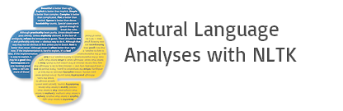

NLTK is a leading platform for building Python programs to work with human language data. It provides easy-to-use interfaces to over 50 corpora and lexical resources such as WordNet, along with a suite of text processing libraries for classification, tokenization, stemming, tagging, parsing, and semantic reasoning, wrappers for industrial-strength NLP libraries, and an active discussion forum.

NLTK (Natural Language Toolkit) Library is a suite that contains libraries and programs for statistical language processing. It is one of the most powerful NLP libraries, which contains packages to make machines understand human language and reply to it with an appropriate response.

**MySQL**

MySQL tutorial provides basic and advanced concepts of MySQL. Our MySQL tutorial is designed for beginners and professionals. MySQL is a relational database management system based on the Structured Query Language, which is the popular language for accessing and managing the records in the database. MySQL is open-source and free software under the GNU license. It is supported by Oracle Company.MySQL database that provides for how to manage database and to manipulate data with the help of various SQL queries. These queries are: insert records, update records, delete records, select records, create tables, drop tables, etc. There are also given MySQL interview questions to help you better understand the MySQL database.



MySQL is currently the most popular database management system software used for managing the relational database. It is open-source database software, which is supported by Oracle Company. It is fast, scalable, and easy to use database management system in comparison with Microsoft SQL Server and Oracle Database. It is commonly used in conjunction with PHP scripts for creating powerful and dynamic server-side or web-based enterprise applications. It is developed, marketed, and supported by MySQL AB, a Swedish company, and written in C programming language and C++ programming language. The official pronunciation of MySQL is not the My Sequel; it is My Ess Que Ell. However, you can pronounce it in your way. Many small and big companies use MySQL. MySQL supports many Operating Systems like Windows, Linux, MacOS, etc. with C, C++, and Java languages.

**WampServer**

WampServer is a Windows web development environment. It allows you to create web applications with Apache2, PHP and a MySQL database. Alongside, PhpMyAdmin allows you to manage easily your database.



WampServer is a reliable web development software program that lets you create web apps with MYSQL database and PHP Apache2. With an intuitive interface, the application features numerous functionalities and makes it the preferred choice of developers from around the world. The software is free to use and doesn’t require a payment or subscription.

**OpenCV2(Computer version 2)**

Cv2 is a popular Python library used for computer vision tasks such as image and video processing, object detection, and facial recognition. Here's an overview of the documentation for cv2:



**Installation**: The cv2 library can be installed using pip, a package manager for Python. The installation instructions can be found in the cv2 documentation.

**Image Processing**: The cv2 library provides a wide range of functions for image processing tasks such as image smoothing, edge detection, color space conversions, and image resizing. The documentation provides detailed information on each function along with examples of how to use them.

**Video Processing**: The cv2 library can be used to process video streams in real-time. The documentation provides examples of how to capture video from a camera, extract frames from a video, and save a video stream to a file.

**Object Detection**: The cv2 library can be used for object detection tasks such as face detection, pedestrian detection, and object tracking. The documentation provides examples of how to use pre-trained models for these tasks and how to train your own models.

**GUI Programming**: The cv2 library can be used to create graphical user interfaces (guis) for computer vision applications. The documentation provides examples of how to create windows and display images, how to handle mouse events, and how to create trackbars and buttons.

**Miscellaneous Functions**: The cv2 library provides several other functions such as drawing functions, feature detection, and camera calibration. The documentation provides detailed information on each function along with examples of how to use them.

The cv2 documentation is well-organized and easy to navigate. It provides detailed information on each function along with examples of how to use them, making it a great resource for anyone working with computer vision tasks in Python.

**Kivy :**



**Kivy** is a [free](https://en.wikipedia.org/wiki/Free_Software) and [open source](https://en.wikipedia.org/wiki/Open_Source_Software) [Python](https://en.wikipedia.org/wiki/Python_(programming_language)) [framework](https://en.wikipedia.org/wiki/Application_framework) for developing [mobile apps](https://en.wikipedia.org/wiki/Mobile_app) and other [multitouch](https://en.wikipedia.org/wiki/Multitouch" \o "Multitouch) [application software](https://en.wikipedia.org/wiki/Application_software) with a [natural user interface (NUI)](https://en.wikipedia.org/wiki/Natural_User_Interface). It is distributed under the terms of the [MIT License](https://en.wikipedia.org/wiki/MIT_License), and can run on [Android](https://en.wikipedia.org/wiki/Android_(operating_system)), [iOS](https://en.wikipedia.org/wiki/IOS), [Linux](https://en.wikipedia.org/wiki/Linux), [macOS](https://en.wikipedia.org/wiki/MacOS" \o "MacOS), and [Windows](https://en.wikipedia.org/wiki/Microsoft_Windows).

Kivy is the main framework developed by the Kivy organization,[[3]](https://en.wikipedia.org/wiki/Kivy_(framework)#cite_note-3) alongside Python for Android,[[4]](https://en.wikipedia.org/wiki/Kivy_(framework)#cite_note-4) Kivy for iOS,[[5]](https://en.wikipedia.org/wiki/Kivy_(framework)#cite_note-5) and several other libraries meant to be used on all platforms. In 2012, Kivy got a $5000 grant from the [Python Software Foundation](https://en.wikipedia.org/wiki/Python_Software_Foundation) for porting it to Python 3.3.[[6]](https://en.wikipedia.org/wiki/Kivy_(framework)#cite_note-6) Kivy also supports the [Raspberry Pi](https://en.wikipedia.org/wiki/Raspberry_Pi) which was funded through [Bountysource](https://en.wikipedia.org/wiki/Bountysource" \o "Bountysource).[[7]](https://en.wikipedia.org/wiki/Kivy_(framework)#cite_note-7)

The framework contains all the elements for building an application such as:

* extensive input support for [mouse](https://en.wikipedia.org/wiki/Computer_mouse), [keyboard](https://en.wikipedia.org/wiki/Computer_keyboard), [TUIO](https://en.wikipedia.org/wiki/TUIO), and OS-specific multitouch events;
* a graphic library using only [OpenGL ES 2](https://en.wikipedia.org/wiki/OpenGL_ES), and based on [Vertex Buffer Object](https://en.wikipedia.org/wiki/Vertex_Buffer_Object) and [shaders](https://en.wikipedia.org/wiki/Shader" \o "Shader);
* a wide range of [widgets](https://en.wikipedia.org/wiki/GUI_widget) that support multitouch;

**CHAPTER 5**

**SYSTEM MODULES**

**5.1 LIST OF MODULES:**

* Registration
* Data validation
* Integration
* Security
* Analytics
* Personalization
* Resource allocation
* Continuous improvement

**5.2 MODULES DESCRIPTION:**

* **Registration Module:**

Handles the automated registration of patients, capturing essential demographic and insurance information.

* **Data Validation Module**:

Ensures the accuracy and completeness of patient data through real-time validation and error checking.

* **Integration Module:**

Facilitates the integration of healthcare data from various sources and systems, ensuring interoperability and comprehensive access to patient information.

* **Security Module**:

Implements robust encryption protocols, access controls, and other security measures to protect patient data and ensure compliance with regulatory standards.

* **Analytics Module**:

Utilizes advanced analytics and machine learning algorithms to analyze healthcare data, derive actionable insights, and support decision-making processes.

* **Personalization Module:**

Tailors healthcare services and interventions to individual patient needs and preferences based on insights derived from analytics.

* **Resource Optimization Module**:

Optimizes resource allocation, including staff, equipment, and facilities, based on predictive analytics to meet patient demand efficiently.

* **Monitoring and Reporting Module**:

Tracks system performance, monitors key metrics, and generates reports to support continuous improvement efforts and compliance requirements.

* **User Interface Module**:

Provides an intuitive and user-friendly interface for healthcare providers, administrative staff, and patients to interact with the system effectively.

These modules work together seamlessly to automate patient registration, optimize data management, improve decision-making, enhance patient care, and drive operational efficiency within healthcare organizations.

**5.3.Performance Analysis**

Performance analysis of the AI-powered patient registration and data optimization system involves a multifaceted evaluation of its effectiveness in transforming healthcare processes. Key metrics such as data accuracy, efficiency, error rate reduction, and interoperability are assessed to gauge the system's impact. The system's ability to integrate data from various sources, ensure data security, and provide predictive analytics for resource optimization and personalized care is crucial. Additionally, analyzing the system's adaptability to changing healthcare requirements and its compliance with regulatory standards is essential. Patient experience improvements, including reduced wait times and simplified processes, are also considered. Cost-effectiveness and reliability are evaluated to determine the system's overall efficiency and sustainability. Continuous feedback from stakeholders, along with tracking performance metrics, drives ongoing improvements to ensure the system's effectiveness in enhancing healthcare delivery.

**CHAPTER 6**

**SYSTEM ARCHITECTURE**

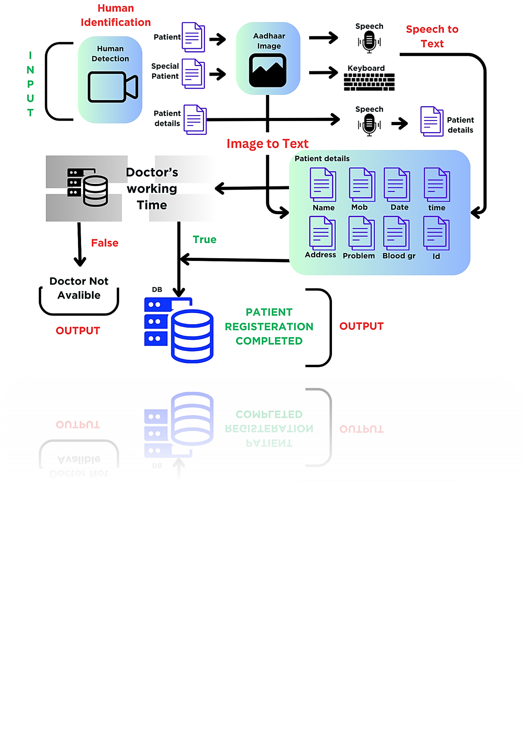

Figure 6.1

**CHAPTER 7**

**SYSTEM DESIGN**

**Data-flow Diagram:**

A data-flow diagram is a way of representing a flow of data through a process or a system (usually an information system). The DFD also provides information about the outputs and inputs of each entity and the process itself.

**Class Diagram:**

A class diagram is an illustration of the relationships and source code dependencies among classes in the Unified Modeling Language (UML).

**Usecase Diagram**:

A use case diagram is a way to summarize details of a system and the users within that system. It is generally shown as a graphic depiction of interactions among different elements in a system.

**Activity Diagram**:

An activity diagram is a behavioral diagram i.e. it depicts the behavior of a system. An activity diagram portrays the control flow from a start point to a finish point showing the various decision paths that exist while the activity is being executed.

**7.1 Dataflow Diagrams**

A data-flow diagram is a way of representing a flow of a data of a process or a system. The DFD also provides information about the outputs and inputs of each entity and the process itself.

**Level 0**

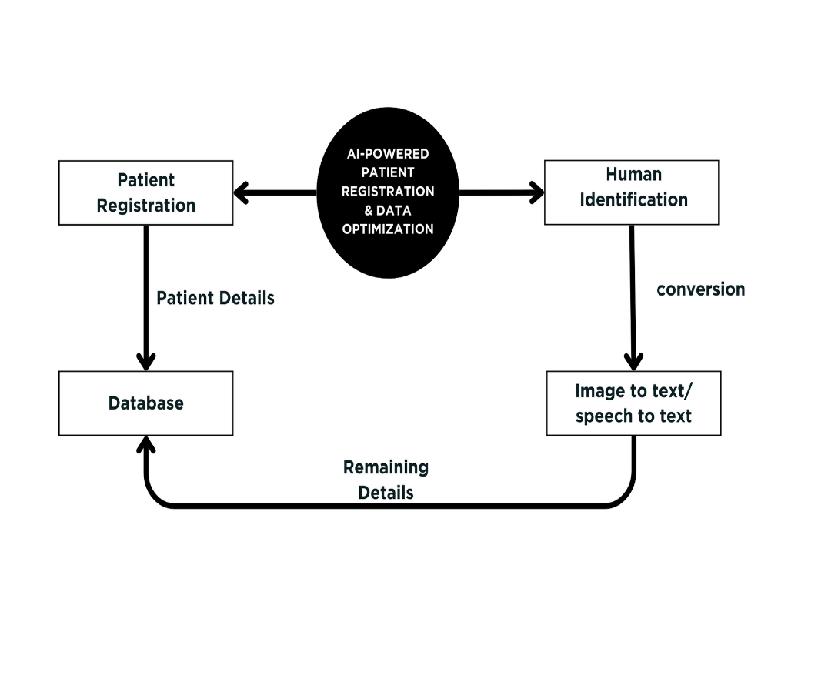A level 0 data flow diagram (DFD), also known as a context diagram, shows a data system as a whole and emphasizes the way it interacts with external entities.

Figure 7.1.1

**Level 1**

A context level DFD is the most basic form of DFD. It aims to show how the entire system works at a glance.

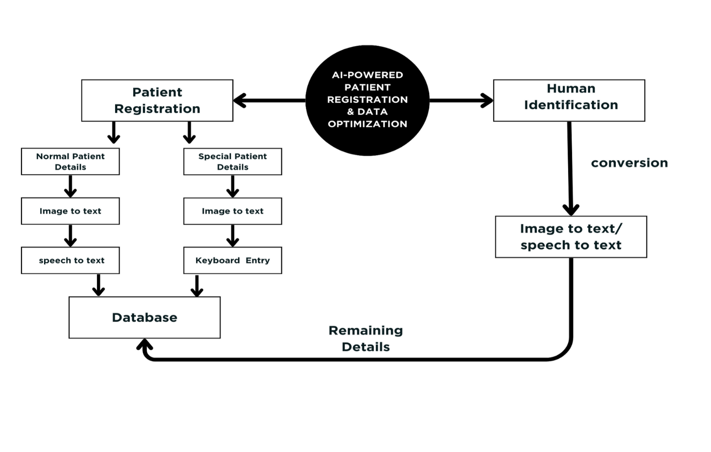

Figure 7.1.2

**Level 2**

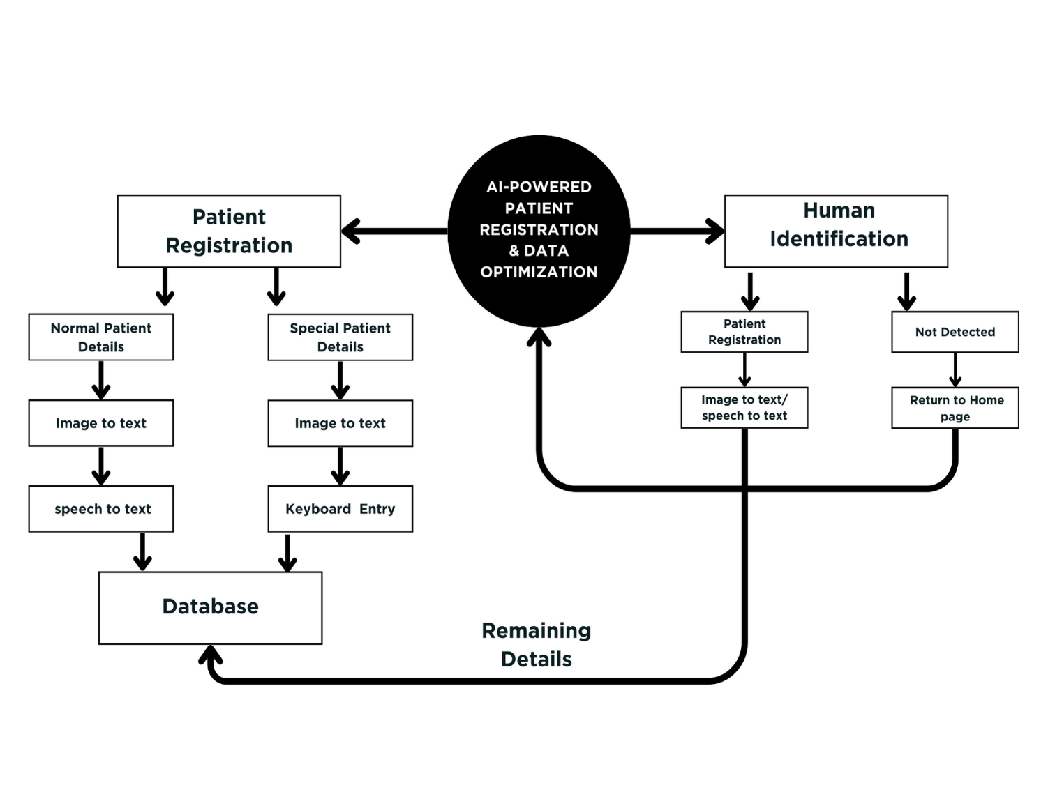A level 2 data flow diagram (DFD) offers a more detailed look at the processes that make up an information system than a level 1 DFD does. It can be used to plan or record the specific makeup of a system.

Figure 7.1.3

**7.2 Use case diagram**

A use case diagram doesn't go into a lot of detail—for example, don't expect it to model the order in which steps are performed. Instead, a proper use case diagram depicts a high-level overview of the relationship between use cases, actors, and systems. Experts recommend that use case diagrams be used to supplement a more descriptive textual use case.

UML is the modeling toolkit that you can use to build your diagrams. Use cases are represented with a labeled oval shape. Stick figures represent actors in the process, and the actor's participation in the system is modeled with a line between the actor and use case. To depict the system boundary, draw a box around the use case itself.

UML use case diagrams are ideal for:

* Representing the goals of system-user interactions
* Defining and organizing functional requirements in a system
* Specifying the context and requirements of a system
* Modeling the basic flow of events in a use case

**Patient - A**

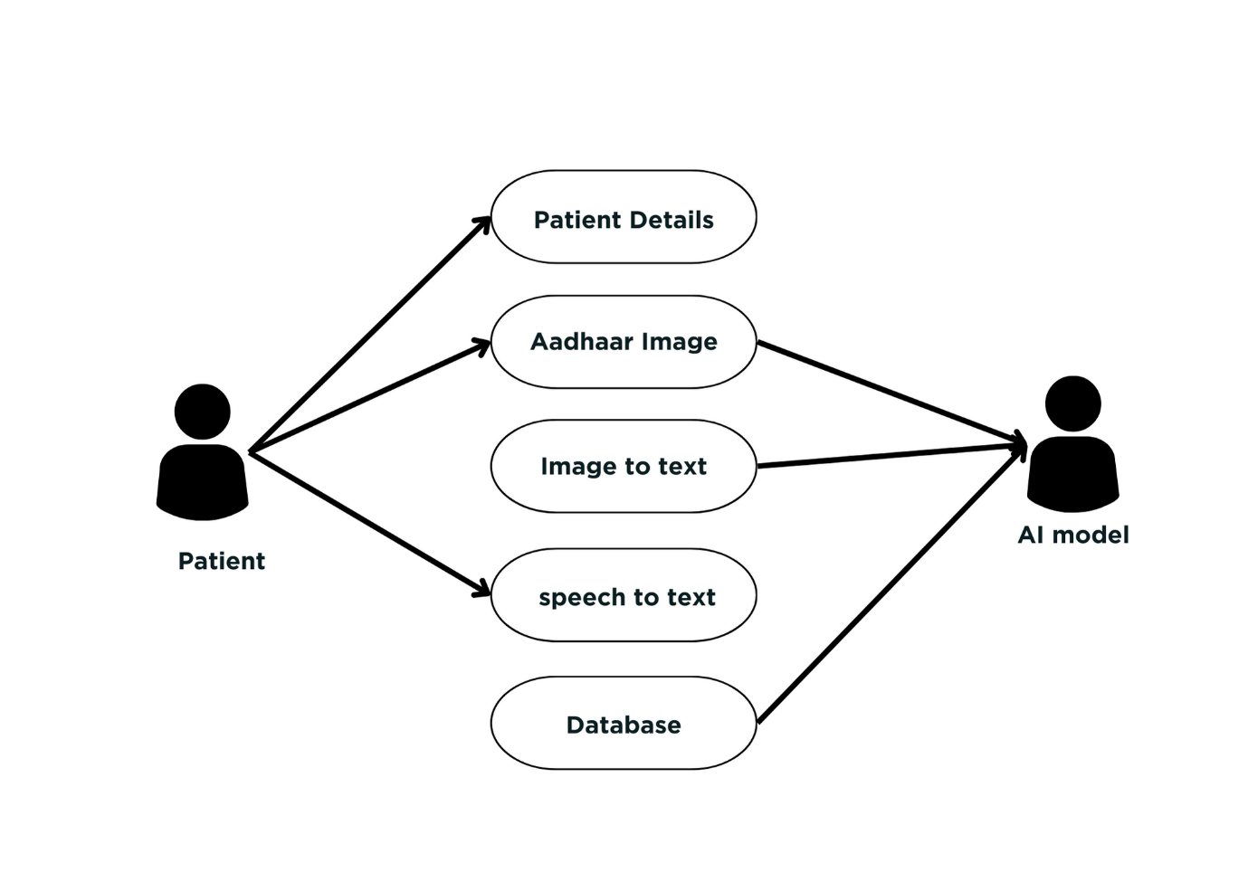

Figure 7.2.1

**AI - Database**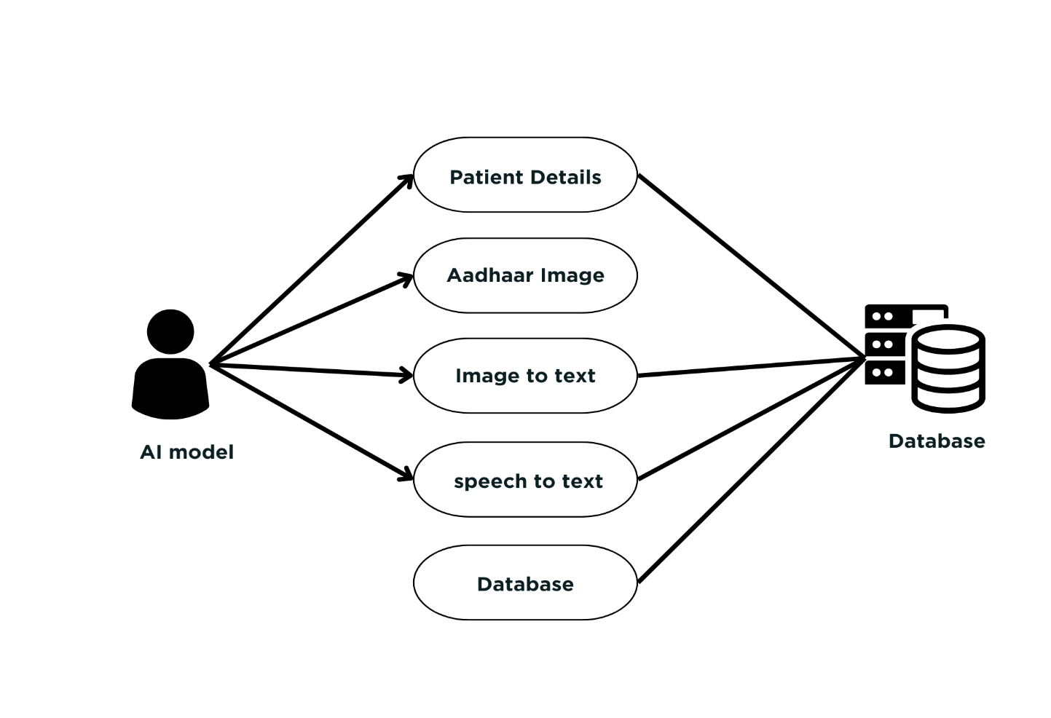

Figure 7.2.

**7.3 Class diagram**

In UML, class diagrams are one of six types of structural diagram. Class diagrams are fundamental to the object modeling process and model the static structure of a system. Depending on the complexity of a system, you can use a single class diagram to model an entire system, or you can use several class diagrams to model the components of a system.

Class diagrams are the blueprints of your system or subsystem. You can use class diagrams to model the objects that make up the system, to display the relationships between the objects, and to describe what those objects do and the services that they provide.

Class diagrams are useful in many stages of system design. In the analysis stage, a class diagram can help you to understand the requirements of your problem domain and to identify its components. In an object-oriented software project, the class diagrams that you create during the early stages of the project contain classes that often translate into actual software classes and objects when you write code. Later, you can refine your earlier analysis and conceptual models into class diagrams that show the specific parts of your system, user interfaces, logical implementations, and so on. Your class diagrams then become a snapshot that describes exactly how your system works, the relationships between system components at many levels, and how you plan to implement those components.

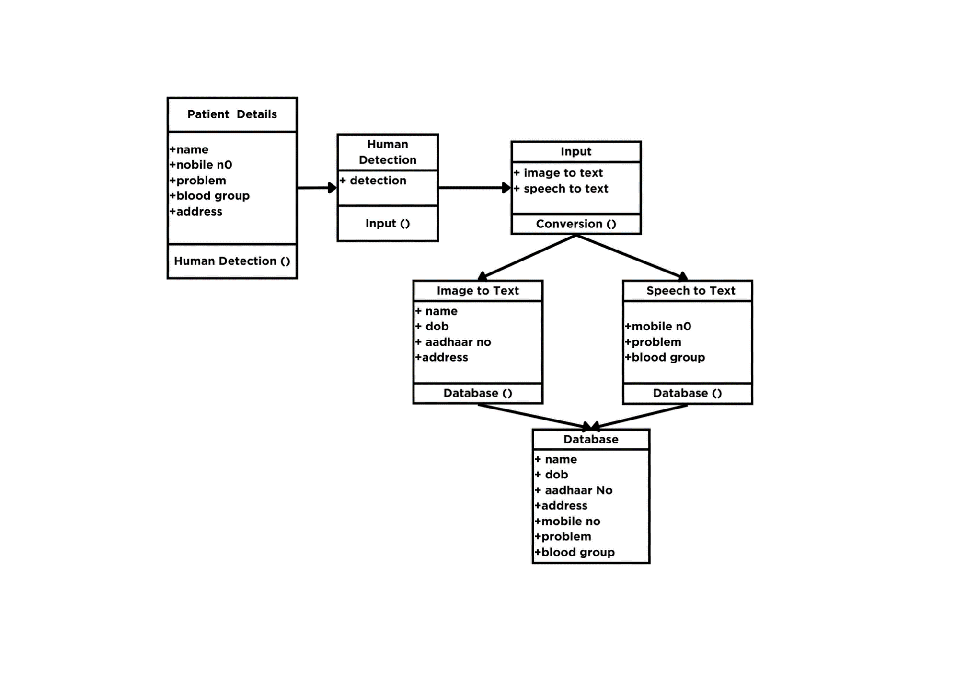

Figure 7.3.1

**7.4 Sequence Diagram**

A sequence diagram is a type of interaction diagram because it describes how—and in what order—a group of objects works together. These diagrams are used by software developers and business professionals to understand requirements for a new system or to document an existing process. Sequence diagrams are sometimes known as event diagrams or event scenarios.  
Note that there are two types of sequence diagrams: UML diagrams and code-based diagrams. The latter is sourced from programming code and will not be covered in this guide. Lucidchart’s [UML diagramming software](https://www.lucidchart.com/pages/examples/uml_diagram_tool) is equipped with all the shapes and features you will need to model both.

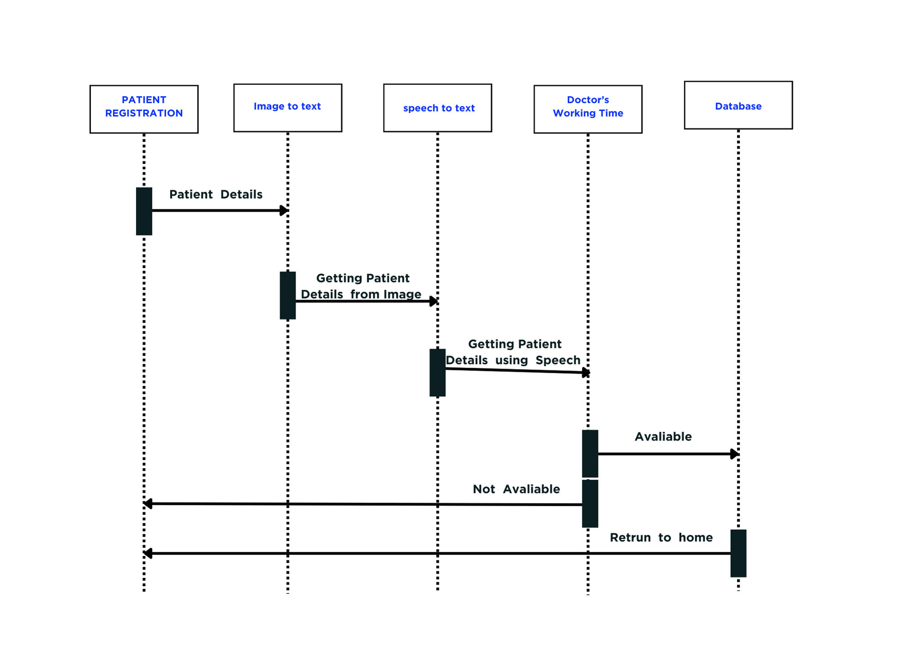

Figure 7.4.1

**7.5 ER Diagram**

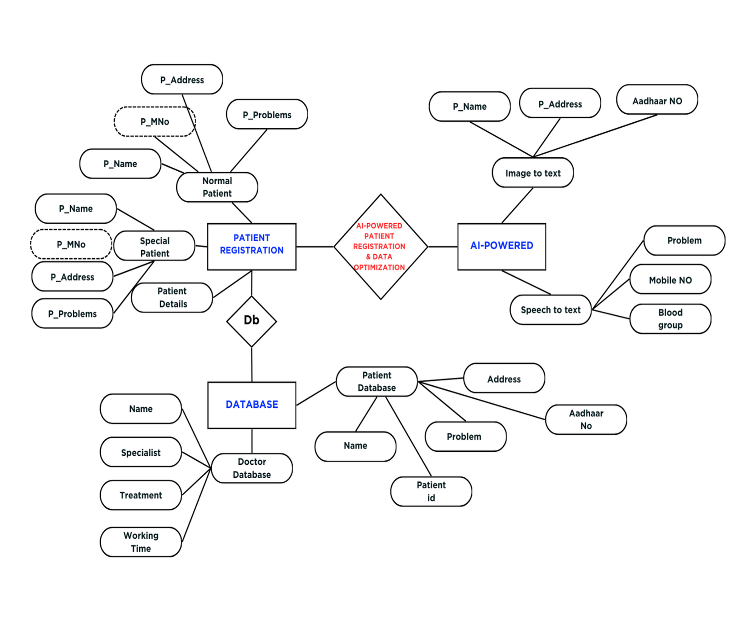

Figure 7.5.1

**CHAPTER 8**

**SYSTEM IMPLEMENTATION**

**8.1 CODING**

class AI_Register(MDApp):

def build(self):

self.theme_cls.theme_style = "Dark"

self.theme_cls.primary_palette = "Blue"

self.time_remaining = 0 # Initial time in seconds

self.is_running = False

# if True:

# thread7 = threading.Thread(target=self.c1)

# thread7.start()

mydb = mysql.connector.connect(

host = "localhost",

user = "root",

passwd = "",

database = "second1_db"

)

c = mydb.cursor()

c.execute("CREATE DATABASE IF NOT EXISTS second1_db")

c.execute("""CREATE TABLE if not exists patient_main1 (Id VARCHAR(5),name VARCHAR(15),mobile_NO VARCHAR(20),Gender VARCHAR(5),Blood_group VARCHAR(10),DOB VARCHAR(20),problem VARCHAR(20),Aadhar_no VARCHAR(20),Address VARCHAR(100),Date VARCHAR(10))""")

mydb.commit()

mydb.close()

return Manager()

def human_face(self):

if True:

human_cascade = cv2.CascadeClassifier(cv2.data.haarcascades + 'haarcascade_frontalface_default.xml')

cap = cv2.VideoCapture(0)

m=1

while True:

ret, frame = cap.read()

gray = cv2.cvtColor(frame, cv2.COLOR_BGR2GRAY)

humans = human_cascade.detectMultiScale(gray, scaleFactor=1.1, minNeighbors=5, minSize=(30, 30))

for (x, y, w, h) in humans:

cv2.rectangle(frame, (x, y), (x+w, y+h), (0, 255, 0), 2)

cv2.imshow("Human Detection", frame)

# print(m//10)

if m>=50 and frame.all()==True:

time.sleep(2)

py.hotkey('alt'+'f4')

py.typewrite('q')

now=dt.now()

cv2.imwrite("out/"+(str(dd.date.today()))+str(m)+'.jpg',frame)

m=0

if cv2.waitKey(1) & 0xFF == ord('q'):

break

m=m+1

cap.release()

now=dt.now()

self.root.ids.t1.text = 'Time : '+str(now.strftime("%H:%M:%S"))

self.root.ids.d1.text = 'Date : '+str(dd.date.today())

cv2.destroyAllWindows()

text='Human face successfully dectected'

self.text_to_speech(text)

def speech_to_textpp(self,say):

recognizer = sr.Recognizer()

with sr.Microphone() as source:

print(say)

audio = recognizer.listen(source)

try:

text = recognizer.recognize_google(audio)

print("You said:", text)

self.show(text)

self.root.ids.id1.text=text

except sr.UnknownValueError:

print("Could not understand audio")

# self.root.ids.mobile.text='ghfygf'

self.speech_to_textpp(say)

except sr.RequestError as e:

print(f"Could not request results from Google Web Speech API; {e}")

# self.speech_to_textm(say)

count = 0

def c3(self):

# Start the clock

# clock=Clock()

Clock.schedule_interval(self.Callback_Clock3, 1)

now=dt.now()

global tn

tn =int(now.strftime("%H"))

# if tn>12:

# global tn

# tn=tn-12

def Callback_Clock3(self, dt):

# now=dt.now()

self.count = self.count + 1

count=self.count

print(count)

if self.count==1:

for i in range (1,3):

self.face_cap(i)

elif self.count==2:

self.root.current='ten'

elif self.count==20:

c=[]

for i in range (1000,4000):

c.append(i)

ch=random.choice(c)

self.root.ids.id2.text=str(ch)

self.root.ids.mobile.text=self.root.ids.mob1.text

self.root.ids.blood.text=self.root.ids.blo1.text

self.root.ids.problem.text=self.root.ids.pro1.text

self.detail()

elif self.count==21:

self.root.current='sixth'

elif self.count==31:

d=['fever,cold,head ache,body pain,injury,fire injury,stomach pain','leg facher,hand facher,finger facher,hip_bone facher,back_bone facher','left leg nerve,right leg nerve,neck nerve,right hand nerve,left hand nerve','heart problem']

for i in (d):

if str(self.root.ids.pro1.text).casefold() in i.casefold():

mydb = mysql.connector.connect(

host = "localhost",

user = "root",

passwd = "",

database = "second1_db"

)

c = mydb.cursor()

c.execute(f"SELECT Work_time FROM doctor_details WHERE Treatment='{i}'")

d = c.fetchall()

# print(d)

ww= str(d[0]).removeprefix("('").removesuffix("',)")

wf=int(ww[0])

wl=int(ww[-1])

t=[]

for j in range(int(wf)):

t.append(wf)

wf+=1

# if wf>12:

# wf=1

# now=dt.now()

if int(tn) in t:

self.d_show(i)

self.add()

self.root.current='seven'

# self.new()

t.clear()

else:

self.new()

self.root.current='eleven'

mydb.commit()

mydb.close()

elif self.count==37:

# self.root.current='sixth'

self.new()

elif self.count==38:

Clock.unschedule(self.Callback_Clock3)

self.count =0

self.root.current='logo'

count = 0

def c2(self):

# Start the clock

# clock=Clock()

Clock.schedule_interval(self.Callback_Clock2, 1)

def Callback_Clock2(self, dt):

self.count = self.count + 1

count=self.count

print(count)

if self.count==1:

self.root.current='eigth'

elif self.count==2:

say='Say Patient Id Number... '

self.speech_to_textpp(say)

elif self.count==3:

self.root.current='ninth'

elif self.count==13:

Clock.unschedule(self.Callback_Clock2)

self.count =0

self.root.current='logo'

count = 0

def c1(self):

# Start the clock

# clock=Clock()

Clock.schedule_interval(self.Callback_Clock1, 1)

def Callback_Clock1(self, dt):

self.count = self.count + 1

count=self.count

print(count)

if self.count==2:

self.human_face()

elif self.count==3:

self.root.current='second'

elif self.count==4:

text='Scan Your Aadhar card '

self.text_to_speech(text)

elif self.count==5:

for i in range (1,3):

self.face_cap(i)

# text='Say your Mobile number Blood Group and Problem '

# self.text_to_speech(text)

elif self.count==6:

self.root.current='Third'

elif self.count==8:

# self.root.current='Third'

say="Say your Mobile number: "

self.speech_to_textm(say)

# self.root.ids.mobile.text='ghfygf'

# self.root.current='forth'

elif self.count==10:

say="Say your Blood Group: "

# text=say

# self.text_to_speech(text)

self.speech_to_textb(say)

# self.root.current='felifth'

elif self.count==12:

say="What is your problem Sir/Mam ?"

# text=say

# self.text_to_speech(text)

self.speech_to_textp(say)

# self.root.ids.name.text='ghfygf'

c=[]

for i in range (1000,4000):

c.append(i)

ch=random.choice(c)

self.root.ids.id2.text=str(ch)

self.detail()

self.root.current='sixth'

elif self.count==22:

# self.add()

d=['fever,cold,head ache,body pain,injury,fire injury,stomach pain','leg facher,hand facher,finger facher,hip_bone facher,back_bone facher','left leg nerve,right leg nerve,neck nerve,right hand nerve,left hand nerve','heart problem']

# d=['fever,cold,head ache,body pain,injury,fire injury,stomach pain','leg facher,hand facher,finger facher,hip_bone facher,back_bone facher','left leg,right leg,neck,right hand,left hand','heart problem']

for i in (d):

if str(self.root.ids.problem.text).casefold() in i.casefold():

mydb = mysql.connector.connect(

host = "localhost",

user = "root",

passwd = "",

database = "second1_db"

)

c = mydb.cursor()

c.execute(f"SELECT Work_time FROM doctor_details WHERE Treatment='{i}'")

d = c.fetchall()

ww= str(d[0]).removeprefix("('").removesuffix("',)")

wf=int(ww[0])

wl=int(ww[-1])

t=[]

for j in range(int(wf)):

t.append(wf)

wf+=1

# if wf>12:

# wf=1

# now=dt.now()

if int(tn) in t:

self.d_show(i)

self.add()

self.root.current='seven'

t.clear()

else:

self.root.current='eleven'

mydb.commit()

mydb.close()

elif self.count==25:

Clock.unschedule(self.Callback_Clock1)

self.count =0

self.new()

self.root.current='logo'

def speech_to_textm(self,say):

recognizer = sr.Recognizer()

with sr.Microphone() as source:

print(say)

audio = recognizer.listen(source)

try:

text = recognizer.recognize_google(audio)

print("You said:", text)

self.root.ids.mobile.text=str(text)

except sr.UnknownValueError:

print("Could not understand audio")

# self.root.ids.mobile.text='ghfygf'

self.speech_to_textm(say)

except sr.RequestError as e:

print(f"Could not request results from Google Web Speech API; {e}")

# self.speech_to_textm(say)

def speech_to_textb(self,say):

recognizer = sr.Recognizer()

with sr.Microphone() as source:

print(say)

audio = recognizer.listen(source)

try:

text = recognizer.recognize_google(audio)

print("You said:", text)

self.root.ids.blood.text=str(text)

except sr.UnknownValueError:

print("Could not understand audio")

# self.root.ids.blood.text = 'ghfygf'

self.speech_to_textb(say)

except sr.RequestError as e:

print(f"Could not request results from Google Web Speech API; {e}")

# self.speech_to_textb(say)

def speech_to_textp(self,say):

recognizer = sr.Recognizer()

with sr.Microphone() as source:

print(say)

audio = recognizer.listen(source)

try:

text = recognizer.recognize_google(audio)

print("You said:", text)

self.root.ids.problem.text=str(text)

except sr.UnknownValueError:

print("Could not understand audio")

# self.root.ids.name.text = 'ghf'

self.speech_to_textb(say)

except sr.RequestError as e:

print(f"Could not request results from Google Web Speech API; {e}")

# self.speech_to_textb(say)

def face_cap(self,i):

if True:

# Clock.unschedule(self.Callback_Clock2)

l=[]

# self.c3()

cap = cv2.VideoCapture(0)

m=0

n=150

while True:

ret, frame = cap.read()

gray = cv2.cvtColor(frame, cv2.COLOR_BGR2GRAY)

cv2.imshow("scan for aadhar",frame)

if n==1:

now=dt.now()

cv2.imwrite("Aadhar/"+(str(dd.date.today()))+str(n+i)+'.jpg',frame)

if i==1:

self.root.ids.image.source="Aadhar/"+(str(dd.date.today()))+str(n+i)+'.jpg'

else:

self.root.ids.images.source="Aadhar/"+(str(dd.date.today()))+str(n+i)+'.jpg'

print(n)

if n==0:

py.hotkey('alt'+'f4')

py.typewrite('q')

if cv2.waitKey(1) & 0xFF == ord('q'):

break

n=n-1

# self.root.ids.cc.text = 'Scan Back side '

cap.release()

cv2.destroyAllWindows()

**8.2 OUTPUT**

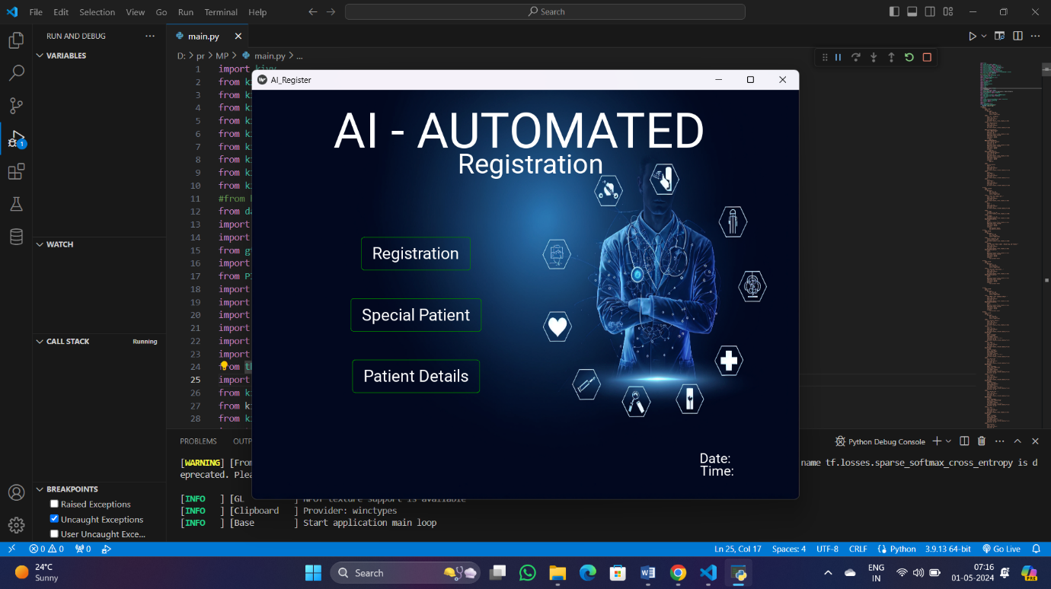

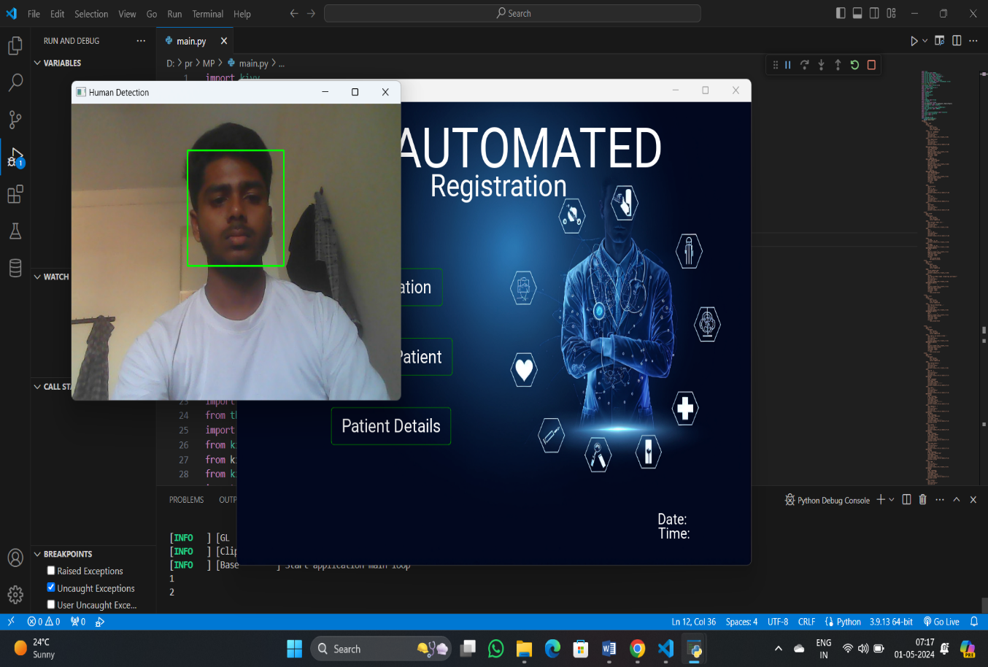

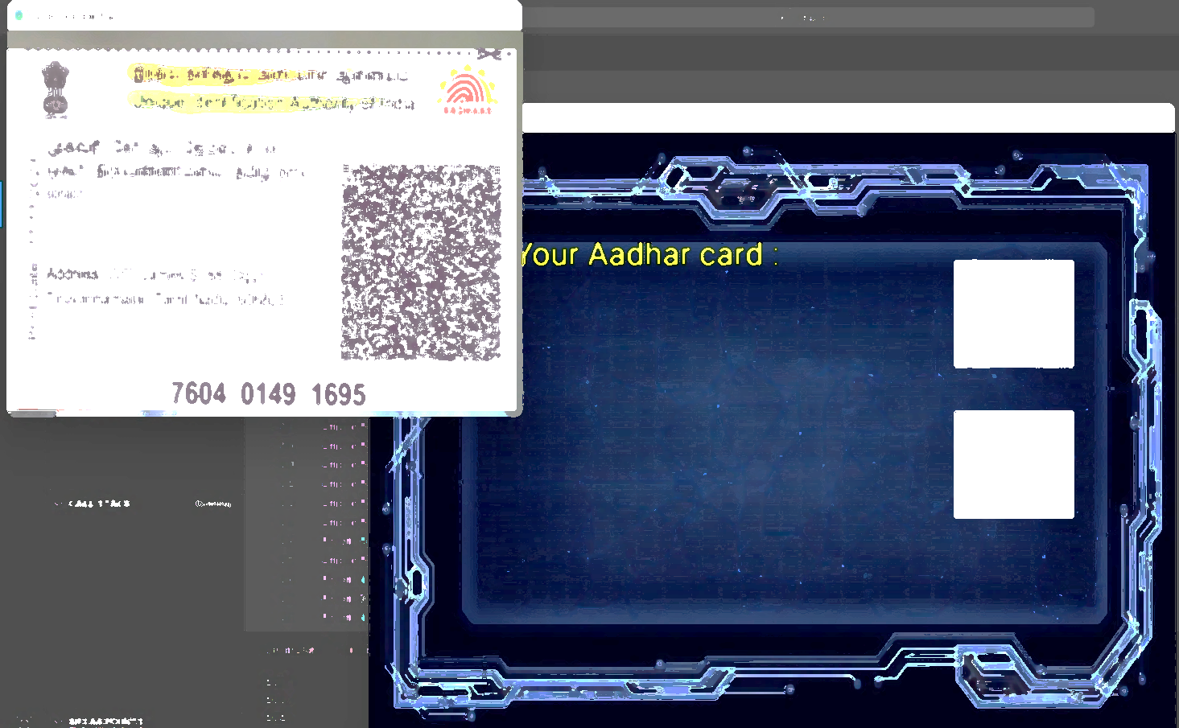

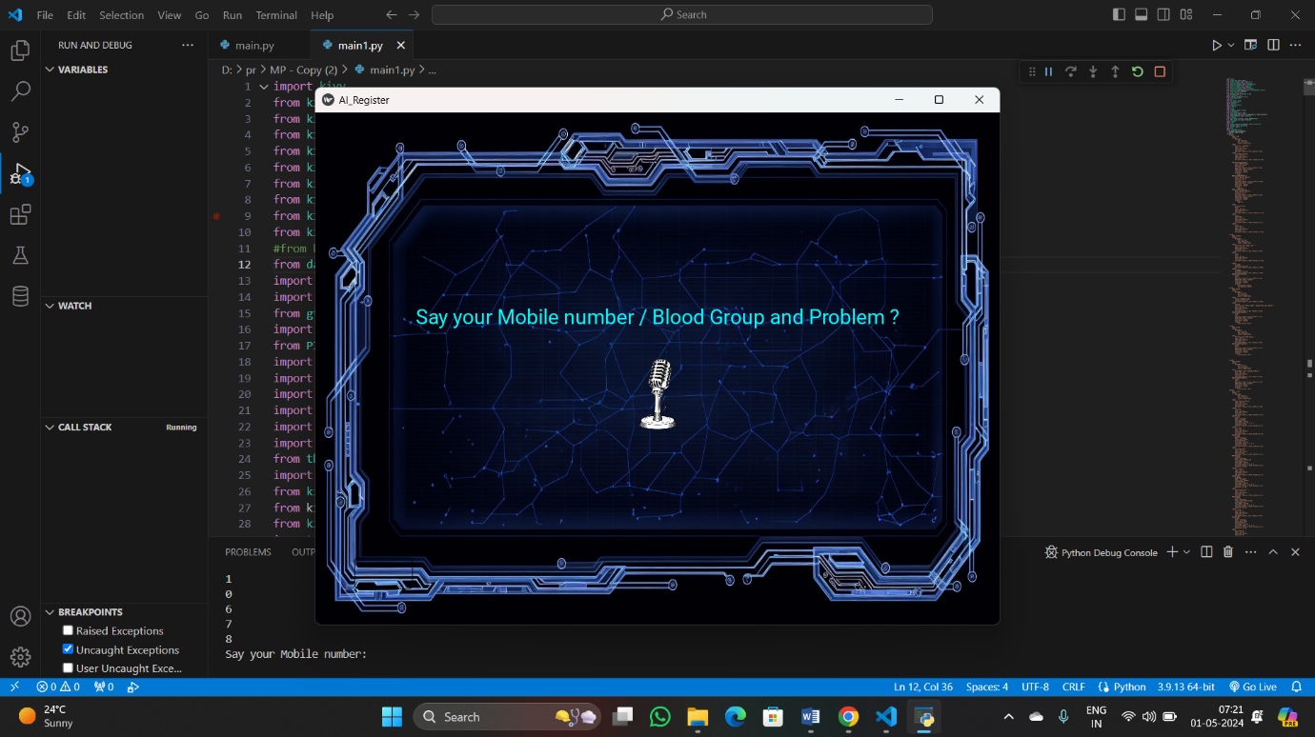

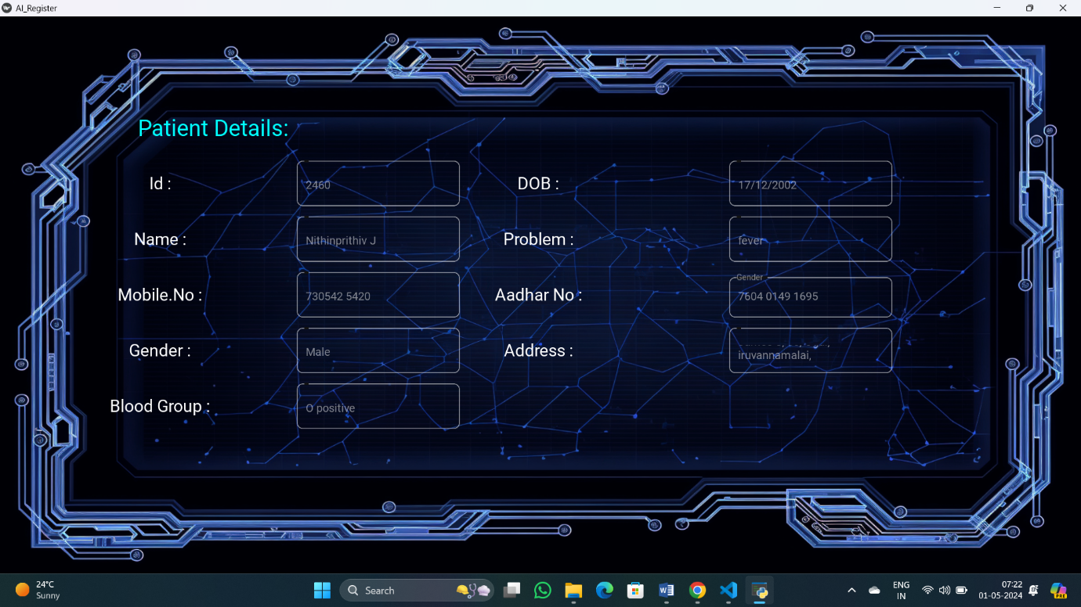

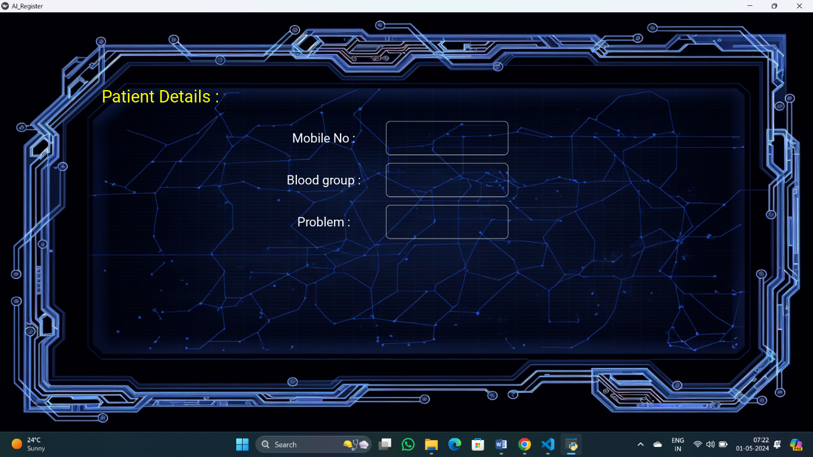

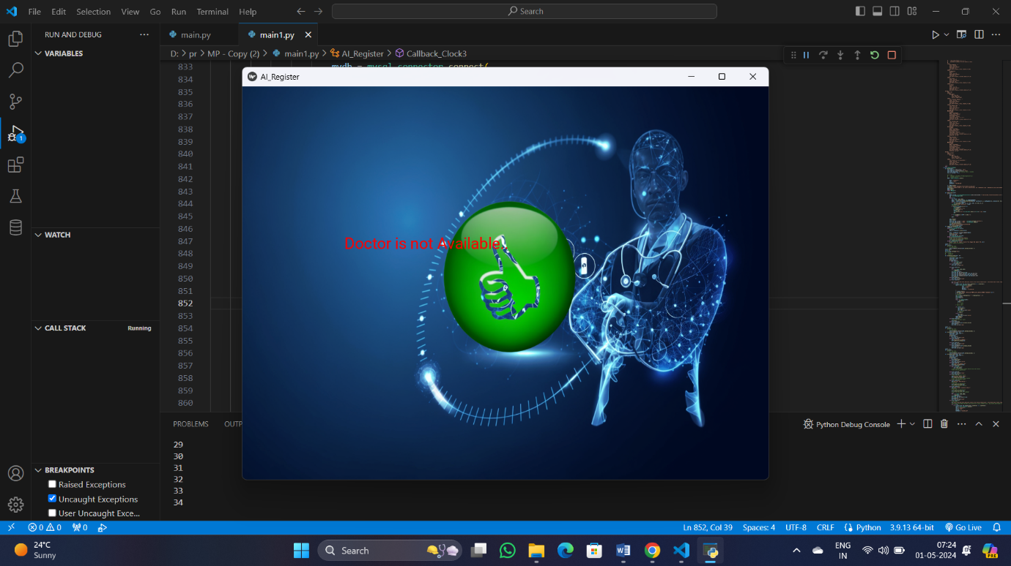

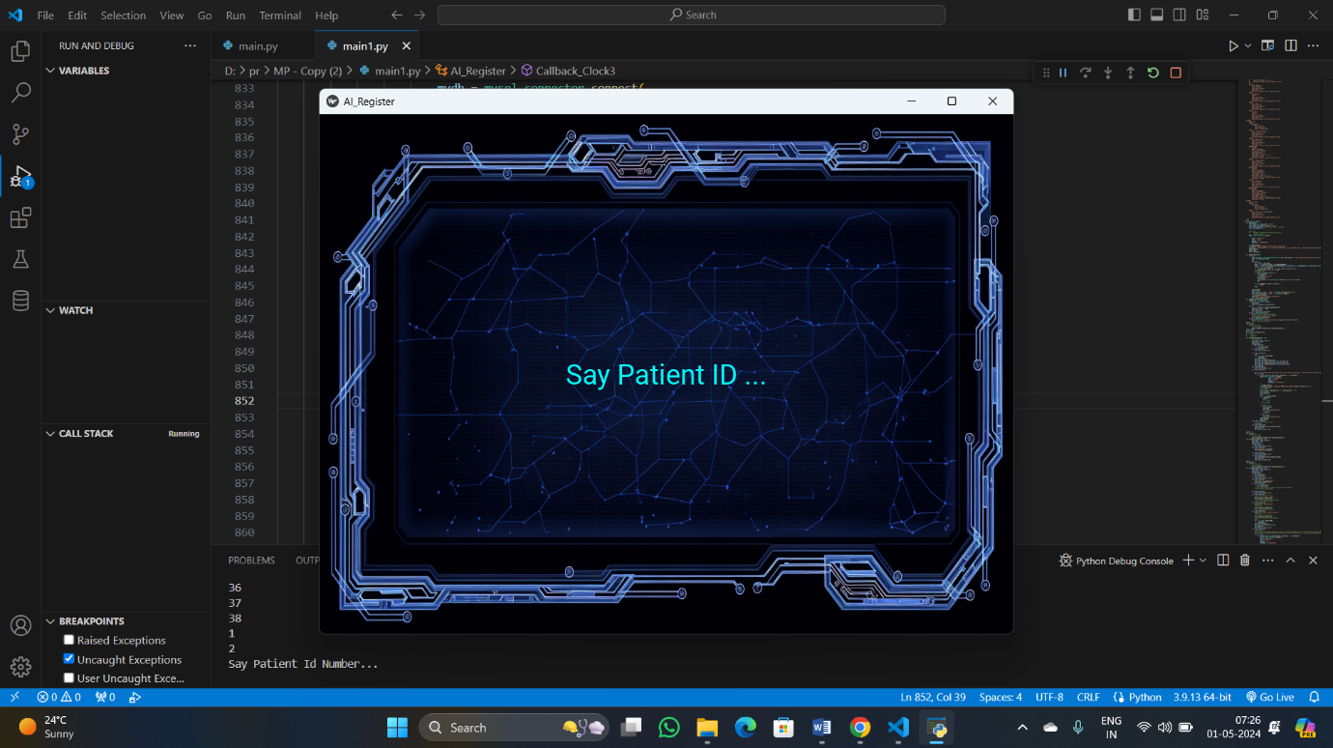

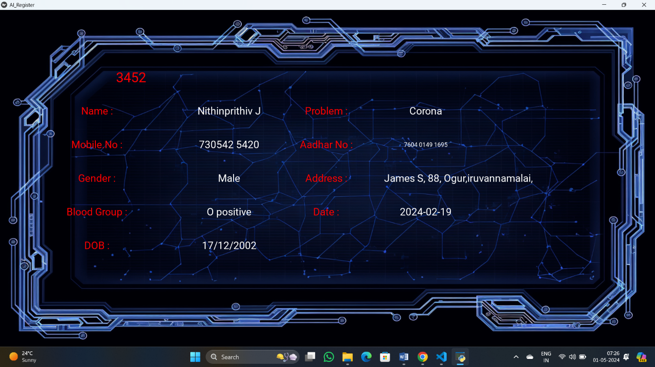

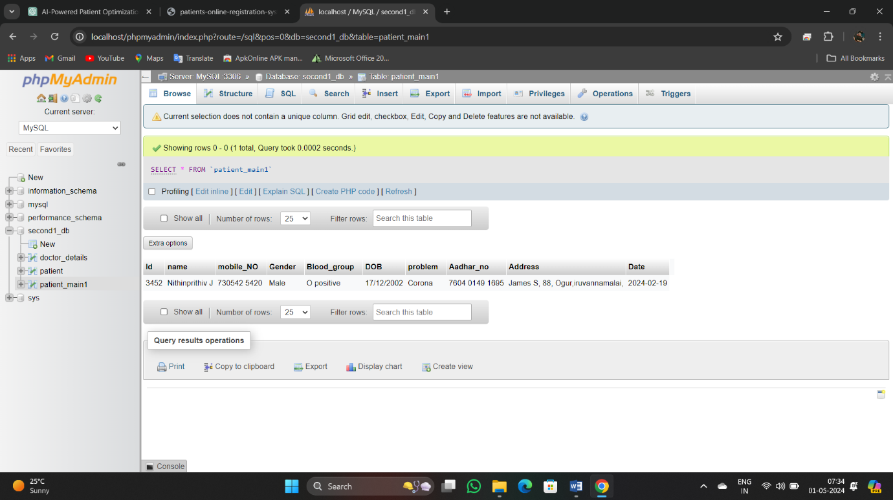

**CHAPTER 9**

**SYSTEM TESTING**

Software testing is a method of assessing the functionality of a software program. There are many different types of software testing but the two main categories are dynamic testing and static testing. Dynamic testing is an assessment that is conducted while the program is executed; static testing, on the other hand, is an examination of the program's code and associated documentation. Dynamic and static methods are often used together. Important aspect, of face recognition is the ability to recognise a single face, under relatively controlled conditions. The essence of such a system is the ability to reject unknown faces. Example applications include a security entry system with controlled lighting, in which a known position and orientation of the face, and a neutral expression, can be assumed; and a workstation security system that continually verifies that the user was the same person that logged on. Rejecting unknown faces is currently an elusive goal, yet it is vital to such high security applications.

**9.1 System Testing**

In this phase of methodology, testing was carried out on the several application modules. Different kind of testing was done on the modules which are described in the following sections. Generally, tests were done against functional and non-functional requirements of the application following the test cases. Testing the application again and again helped it to become a reliable and stable system.

**9.2 Unit testing:**

Before test an entire software program, make sure the individual parts work properly on their own. Unit testing validates the function of a unit, ensuring that the inputs (one to a few) result in the lone desired output.

This testing type provides the foundation for more complex integrated software.

**9.3 Functional Testing**

Functional Testing is defined as a type of testing which verifies that each function of the software application operates in conformance with the requirement specification. This testing mainly involves black box testing and it is not concerned about the source code of the application. Functional tests were done based on different kind of features and modules of the application and observed that whether the features are met actual project objectives and the modules are hundred percent functional. Functional tests were done based on use cases to determine success or failure of the system implementation and design.

**9.4 Integration Testing**

Integration testing is often done in concert with unit testing. Through integration testing, QA professionals verify that individual modules of code work together properly as a group. Many modern applications run on microservices, self-contained applications that are designed to handle a specific task.

**9.5 White box testing:**

When the software’s internal infrastructure, code and design are visible to the developer or tester, that refers to white-box testing. This approach incorporates various functional testing types, including unit, integration and system testing.

System testing for the AI-powered patient registration and data optimization system involves a methodical process aimed at ensuring its functionality, reliability, and performance align with predefined standards. Beginning with unit testing, individual components undergo rigorous examination to verify their functionality and identify any potential defects. Integration testing follows, assessing how these components interact and ensuring seamless system operation as a whole. Security testing is paramount, where encryption protocols, access controls, and data protection mechanisms are scrutinized to ensure compliance with regulatory standards like HIPAA. Performance testing evaluates the system's responsiveness, scalability, and reliability under various conditions, while user acceptance testing involves end-users assessing the system's suitability and providing valuable feedback. Regression testing confirms that system updates or changes do not compromise existing functionality, and compliance testing ensures adherence to relevant regulations. Usability testing focuses on the user interface and overall ease of use, while deployment testing ensures a smooth transition to operational status. Through these comprehensive testing stages, the system is validated to meet quality standards, regulatory requirements, and user needs before deployment in healthcare settings.

**CHAPTER 10**

**CONCLUSION**

The implementation of the AI-powered patient registration and data optimization system marks a significant step forward in revolutionizing healthcare delivery. By leveraging advanced technology and innovative approaches, this system offers a transformative solution to address the shortcomings of manual processes and fragmented data systems in healthcare. Through comprehensive system testing, including unit testing, integration testing, security testing, performance testing, and user acceptance testing, the system's functionality, reliability, and performance have been rigorously evaluated to ensure alignment with predefined standards and user expectations.The system's advantages are manifold, ranging from improved data accuracy and efficiency to enhanced security measures and personalized care delivery. Automation of patient registration processes streamlines administrative tasks, reducing errors and minimizing wait times for patients. Integration of healthcare data from disparate sources promotes interoperability and comprehensive access to patient information, enabling informed decision-making and seamless care coordination. Advanced analytics and predictive modeling capabilities empower healthcare providers with actionable insights to optimize resource allocation, improve clinical decision-making, and deliver personalized care tailored to individual patient needs and preferences.Moreover, the system prioritizes data security through robust encryption protocols, access controls, and compliance with regulatory standards such as HIPAA. Patient experience is enhanced through simplified registration processes, reduced paperwork, and personalized interactions, fostering trust and satisfaction. Resource optimization ensures efficient allocation of staff, equipment, and facilities to meet patient demand effectively, while continuous monitoring and feedback mechanisms drive ongoing improvements to system functionality and user experience.In essence, the AI-powered patient registration and data optimization system represents a paradigm shift in healthcare delivery, offering a scalable, adaptable, and cost-effective solution to meet the evolving needs of patients, providers, and healthcare organizations. By harnessing the power of artificial intelligence, this system holds the promise of improving healthcare outcomes, enhancing patient experiences, and driving operational efficiencies across the healthcare ecosystem. As technology continues to advance and new challenges emerge, the ongoing refinement and optimization of this system will be essential to ensure its continued success in transforming healthcare delivery for the better.

**CHAPTER 11**

**REFERENCES**

1. Herson J. Patient registration in a cooperative oncology group. Controlled Clinical Trials, 1980; 1: 101-110.
2. Shortliffe E. Biomedical informatics: Computer applications in health care and biomedicine (3rd ed., p. 1060). New York, NY: Springer, 2006.

3. Amatayakul M. Electronic health records: A practical guide for professionals and organizations (5th ed.). Chicago, Ill.: AHIMA, 2013.

4. Friedman C, Wyatt J. Evaluation methods in medical informatics (2nd edn). New York: Springer, 2006.

5. Coa W, Wan Y, Tu H, Shang F, Lie D, Tan Z, et al. A web-based appointment system to reduce waiting for outpatients: A retrospective study. BMC Health Services Research, 2011; 11: 318

6. Act A.. Health insurance portability and accountability act of 1996. Public Law, 104, 191, 1996.

‏ 7. Dent M, Eason K. Electronic information in health and social care-promises and pitfalls. Health Informatics Journal, 2014; 20: 165-167.‏‬

8. Weiping YU, Xiaowen YU, Hao HU, Guimin DU, Liu Z, Wang Y. Use of Hospital Appointment Registration Systems in China: A Survey Study. Global Journal of Health Science, 2013; 5: 193.

‏ 9. Bowen GA. Document analysis as a qualitative research method. Qualitative research journal, 2009; 9: 27-40.‏

10. Zhang M, Zhang C, Sun Q, Cai Q, Yang H, Zhang Y. Questionnaire survey about use of an online appointment booking system in one large tertiary public hospital outpatient service center in China, 2014.

11. Levine DM, Berenson ML, Stephan D. Statistics for managers using Microsoft Excel (Vol. 660). Upper Saddle River, NJ: Prentice Hall, 1999.

12. Vinten G. Participant observation: A model for organizational investigation?. Journal of Managerial Psychology, 1994; 9: 30-38.‏

13. Wani SMA, Sankaranarayanan S. Intelligent mobile hospital appointment scheduling and medicine collection, 2014.

14. Weiss RS. Learning from strangers: The art and method of qualitative interview studies. Simon and Schuster, 1995.‏ 15. Turner DW. Qualitative interview design: A practical guide for novice investigators. The qualitative report, 2010;

15: Dent M, Eason K. Electronic information in health and social care-promises and pitfalls. Health Informatics Journal, 2014;

16. Yates F. Sampling methods for censuses and surveys. Sampling methods for censuses and surveys, 1949.‏

17. Hommel K, Rasmussen S, Madsen M, Kamper AL. The Danish Registry on Regular Dialysis and Transplantation: completeness and validity of incident patient registration. Nephrology Dialysis Transplantation, 2010; 25: 947-951.‏

18. McDermott R. Internal and external validity. Cambridge handbook of experimental political science, 2011; 27-40.‏

19. Oliver GR, Hart SN, Klee EW. Bioinformatics for Clinical Next Generation Sequencing. Clinical chemistry, 2015; 61: 124-135.‏

20. Feuerstein M, Wildhirt SM, Bauernschmitt R, Navab N. Automatic patient registration for port placement in minimally invasixe endoscopic surgery.” Medical Image Computing and Computer-Assisted Intervention–MICCAI. Springer Berlin Heidelberg, 2005; 287-294.

‏ 21. Chen H. Medical informatics knowledge management and data mining in biomedicine. New York, NY, USA, Springer, 2005.